igus introduces two new hybrid roller bearings for easy adjustment in lateral positioning systems

Linear systems are extensively used to move doors, monitors or even panels laterally, or side-to-side. If a low driving force is required, especially for manual adjustments, rollers are often used in the bearing element to reduce friction. However, to absorb the lateral forces, the position of these rollers is crucial. As a solution, igus has introduced two new hybrid roller bearings, which offer smooth adjustment with low drive forces and maximum support.

The WJRM-41-10 has two offset polymer rollers with optimised alignment for better force absorption and easier rolling. The hybrid roller bearing WJRM-31-10 with single roller is in turn the matching, supporting bearing on the opposite side. By using the two roller bearings together, the coefficient of friction can be halved while increasing the service life of the application.

In both bearings, in addition to the rollers, there are sliding elements made of the low-friction tribo-polymer iglidur J. The lubrication-free and maintenance-free material is characterised primarily by its low coefficient of friction. Both bearings can be positioned at the desired bearing clearance.

Using a top plate, the two new roller bearings can be added to a linear guide. To ensure that the bearings can also be used on the matching guide, igus has developed a low-profile hybrid roller rail. This has a special geometry optimised for the hybrid roller bearings. The rail has a simple design without visible holes and is able to attach from the back with sliding blocks. This makes the new rail in combination with the hybrid roller bearings ideal for lateral installations.

For more information about the new hybrid bearings, please visit: www.igus.co.uk/drylin/linear-guide or call igus directly on: 01604 677240

igus resources:
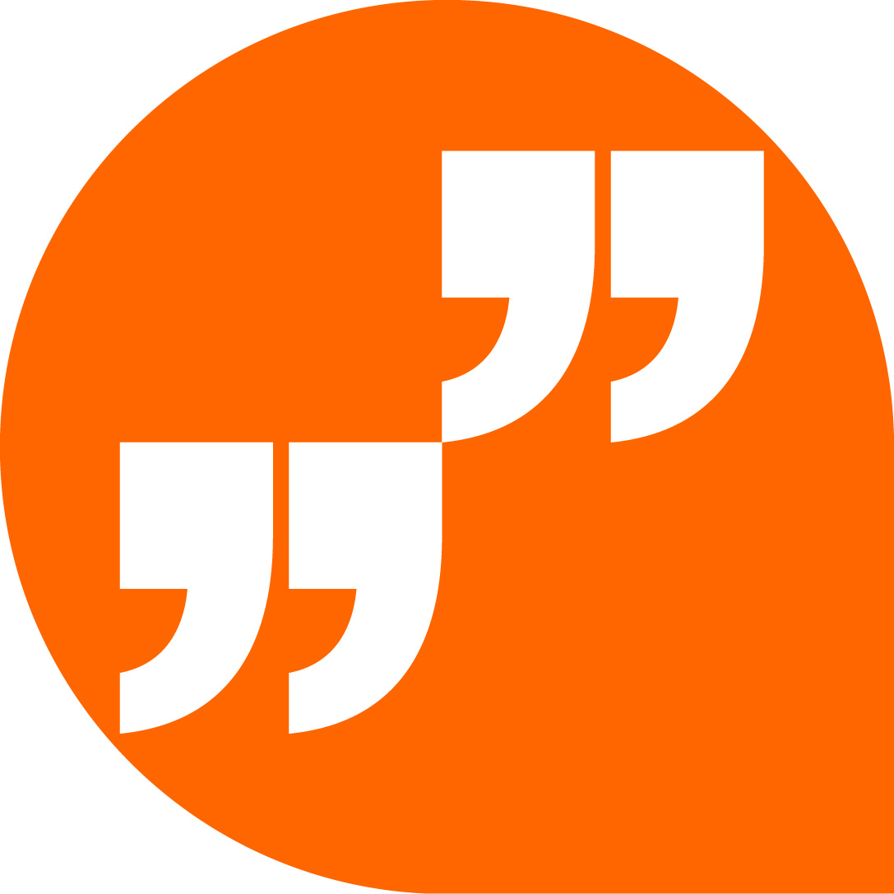 | LiveChat with our technical team at igus.co.uk
 | Follow us at twitter.com/igusUK
 | Watch our videos at igus.co.uk/YouTube
 | Connect to us at igus.co.uk/Facebook
 | Read our blog at blog.igus.co.uk

About igus:
Based in Northampton in the UK and with global headquarters in Cologne, Germany, igus is a leading international manufacturer of energy chain systems and polymer plain bearings. The family-run company is represented in 35 countries and employs 4,150 people around the world. In 2018, igus generated a turnover of 748 million euros with motion plastics, plastic components for moving applications.

With plastic bearing experience since 1964, cable carrier experience since 1971 and continuous-flex cable experience since 1989, igus provides the right solution based on 100,000 products available from stock, with between 1,500 and 2,500 new product introductions each year. igus operates the largest test laboratories and factories in its sector to offer customers quick turnaround times on innovative products and solutions tailored to their needs.

The terms igus, Apiro, chainflex, CFRIP, conprotect, CTD, drylin, dry-tech, dryspin, easy chain, e-chain, e-chain systems, e-ketten, e-kettensysteme, e-skin, flizz, ibow, igear, iglidur, igubal, kineKIT, manus, motion plastics, pikchain, plastics for longer life, readychain, readycable, ReBeL, speedigus, triflex, robolink, and xiros are protected by trademark laws in the Federal Republic of Germany and internationally, where applicable.

All other registered trademarks and trademarks are the property of their respective owners.

For further information, please contact:
Megan Campbell, igus
Tel: 01604 677240
Email: mcampbell@igus.co.uk

Dulcie Elliot, Publitek
Tel: 01582 390980
Email: dulcie.elliot@publitek.com

