Bigger, stronger, faster: new igus drylin linear robots for cost-effective automation

Simple, precise, fast processes: these are the requirements of Cartesian robots. They are used for such things as pick & place applications, sorting systems and medical technology. igus has now developed a line and room linear robot for large workspaces. The two new kinematics systems allow users to move up to 5kg. Both linear robots are available directly from stock with no minimum order quantity.

The drylin line and room linear robots consist of pre-configured linear modules, aluminium linear axes, NEMA stepper motors and encoders. The line robot is for simple pick & place tasks, transporting loads of up to 50 N in a workspace of 800x500mm at a maximum speed of up to 1m/s. For more complex tasks, the room robot can transport loads of up to 50 N in a workspace of 800x800x500mm at a maximum speed of 0.5m/s. Two ZLW toothed belt axes and one GRR gear rack axis ensure precise guidance and lubrication-free operation.

In addition to the stock items, users can assemble their own linear robot with strokes of up to six metres at www.igus.co.uk/drylinEconfigurator and request a quotation from igus. Depending on customer requirements, axis length and various motors can also be configured with such items as energy chains and cables from igus.

For more information about the drylin linear robots, please visit: www.igus.co.uk/info/drive-technology-drylin-gantries or call igus directly on: 01604 677240

igus resources:
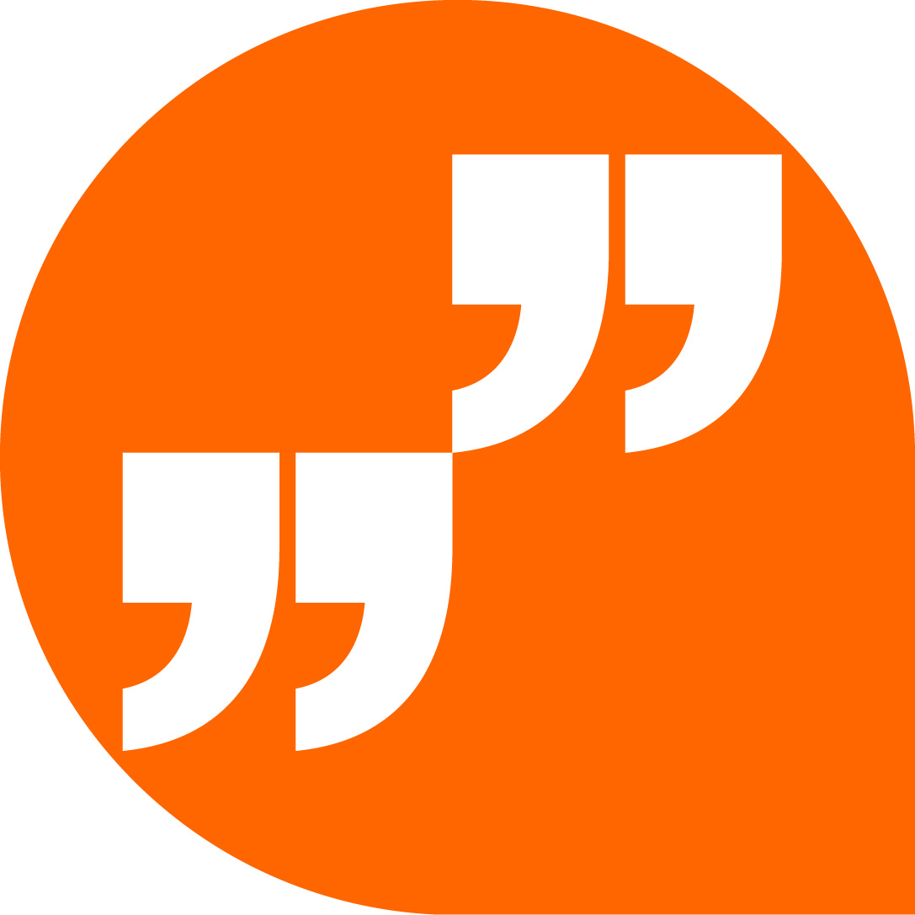 | LiveChat with our technical team at igus.co.uk
 | Follow us at twitter.com/igusUK
 | Watch our videos at igus.co.uk/YouTube
 | Connect to us at igus.co.uk/Facebook
 | Read our blog at blog.igus.co.uk

About igus:
Based in Northampton in the UK and with global headquarters in Cologne, Germany, igus is a leading international manufacturer of energy chain systems and polymer plain bearings. The family-run company is represented in 35 countries and employs 4,150 people around the world. In 2018, igus generated a turnover of 748 million euros with motion plastics, plastic components for moving applications.

With plastic bearing experience since 1964, cable carrier experience since 1971 and continuous-flex cable experience since 1989, igus provides the right solution based on 100,000 products available from stock, with between 1,500 and 2,500 new product introductions each year. igus operates the largest test laboratories and factories in its sector to offer customers quick turnaround times on innovative products and solutions tailored to their needs.

The terms igus, Apiro, chainflex, CFRIP, conprotect, CTD, drylin, dry-tech, dryspin, easy chain, e-chain, e-chain systems, e-ketten, e-kettensysteme, e-skin, flizz, ibow, igear, iglidur, igubal, kineKIT, manus, motion plastics, pikchain, plastics for longer life, readychain, readycable, ReBeL, speedigus, triflex, robolink, and xiros are protected by trademark laws in the Federal Republic of Germany and internationally, where applicable.

All other registered trademarks and trademarks are the property of their respective owners.

For further information, please contact:
Megan Campbell, igus
Tel: 01604 677240
Email: mcampbell@igus.co.uk

Dulcie Elliot, Publitek
Tel: 01582 390980
Email: dulcie.elliot@publitek.com

