drylin delta robot now available with 10x larger working space

igus has introduced a new version of its drylin delta robot with a 10x larger work space volume compared to its original model. This lightweight DLE-DR system for simple pick & place tasks, is delivered as a kit or ready to install product. This guarantees quick operation and saves costs immediately.

The robot consists of three maintenance-free drylin ZLW toothed belt axes with NEMA23 XL encoder stepper motors, lubrication-free igubal coupling joints and matching adapter plates for grippers and motors. This ensures the quick handling of up to 5kg with a precision of ±0.5mm. The new drylin delta robot offers a 10x larger working space with 660mm diameter at 180mm height, which significantly increases the range. A calibrating pin allows the robot to be positioned at the zero point. It is directly fixed to the mounting hub.

The drylin delta robot is suitable for simple assembly activities, pick & place tasks, as well as applications in inspection technology. As a kit, it can be set up in just 30 minutes and is extremely cost-effective. “Even a small or medium-sized company can venture into automation for a few thousand pounds,” says Robert Dumayne, dry-tech director at igus. “The return on investment is less than six months for most applications.”

Depending on the customer's requirements, the new drylin DLE-DR can be delivered within 3 to 7 days as a kit with assembly instructions in a box, or as a ready-to-install system in a transport frame. As an option, the customer can use their own software and control system, or the intuitive and easy-to-use dryve D1 control system from igus.

For more information about the drylin delta robot, please visit: www.igus.co.uk/delta or call igus directly on: 01604 677240

igus resources:
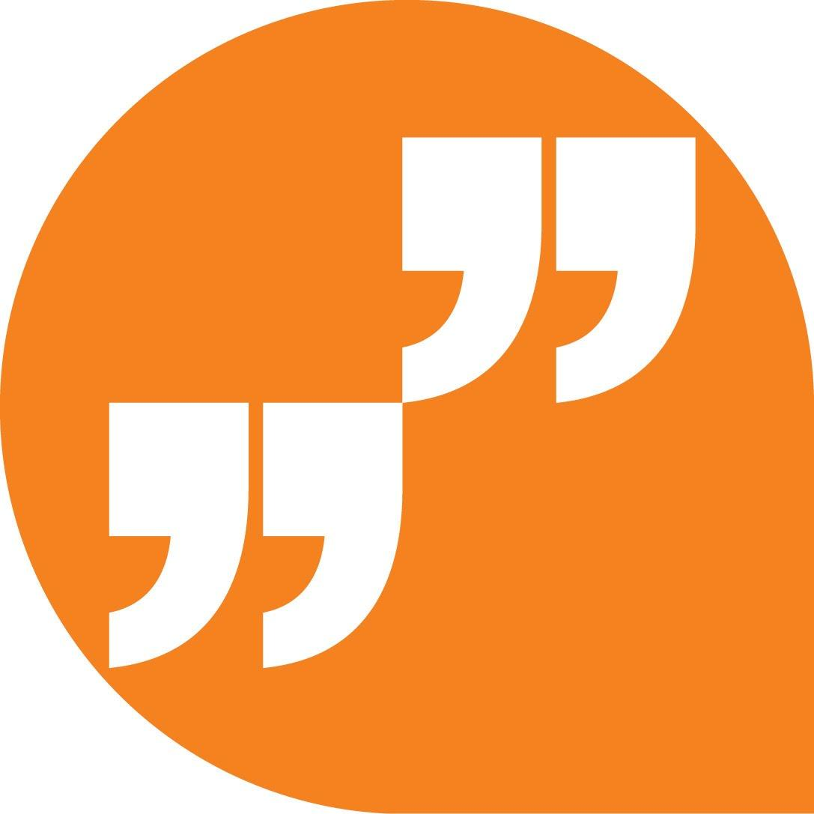 | LiveChat with our technical team at igus.co.uk
 | Follow us at twitter.com/igusUK
 | Watch our videos at igus.co.uk/YouTube
 | Connect to us at igus.co.uk/Facebook
 | Read our blog at blog.igus.co.uk

About igus:
Based in Northampton in the UK and with global headquarters in Cologne, Germany, igus is a leading international manufacturer of energy chain systems and polymer plain bearings. The family-run company is represented in 35 countries and employs 4,150 people around the world. In 2018, igus generated a turnover of 748 million euros with motion plastics, plastic components for moving applications.

With plastic bearing experience since 1964, cable carrier experience since 1971 and continuous-flex cable experience since 1989, igus provides the right solution based on 100,000 products available from stock, with between 1,500 and 2,500 new product introductions each year. igus operates the largest test laboratories and factories in its sector to offer customers quick turnaround times on innovative products and solutions tailored to their needs.

The terms igus, Apiro, chainflex, CFRIP, conprotect, CTD, drylin, dry-tech, dryspin, easy chain, e-chain, e-chain systems, e-ketten, e-kettensysteme, e-skin, flizz, ibow, igear, iglidur, igubal, kineKIT, manus, motion plastics, pikchain, plastics for longer life, readychain, readycable, ReBeL, speedigus, triflex, robolink, and xiros are protected by trademark laws in the Federal Republic of Germany and internationally, where applicable.

All other registered trademarks and trademarks are the property of their respective owners.

For further information, please contact:
Megan Campbell, igus
Tel: 01604 677240
Email: mcampbell@igus.co.uk

Dulcie Elliot, Publitek
Tel: 01582 390980
Email: dulcie.elliot@publitek.com

