Video of the Week – How to increase safety and reliability for collaborative robots

When humans and machines stand shoulder to shoulder on the production line, safety at work is a critical issue. To ensure cables and hoses are reliably and compactly guided on cobots, igus has developed a universal clamp.

The Lean Robotics retaining fixture, which is injection moulded, is available in one universal size, making it very cost-efficient. This week’s video shows how easy and simple they are to install using a Velcro strip. A slim design with rounded edges increases workplace safety by reducing the risk of injury when in contact with the robot.

It will be available in three versions: the standard version has two adjustable Velcro straps in a universal size and a rubber lining inside, so that the straps are fixed on the arm without the risk of slipping. This option is also available with a mounting bracket with and without strain relief. In the third option, the retaining fixture can also be equipped with a protector for additional security.

Originally developed for the triflex R TRC/TRE/TRL 30, 40 and 50 e-chain series, the clamps also accommodate many of the commercially available corrugated hoses.

To watch the video, which shows how to fit the triflex retaining fixtures, please visit: www.igus.co.uk/votwcollabrobots

For more information about the triflex retaining fixtures, please visit: www.igus.co.uk/triflex or call igus directly on: 01604 677240

igus resources:
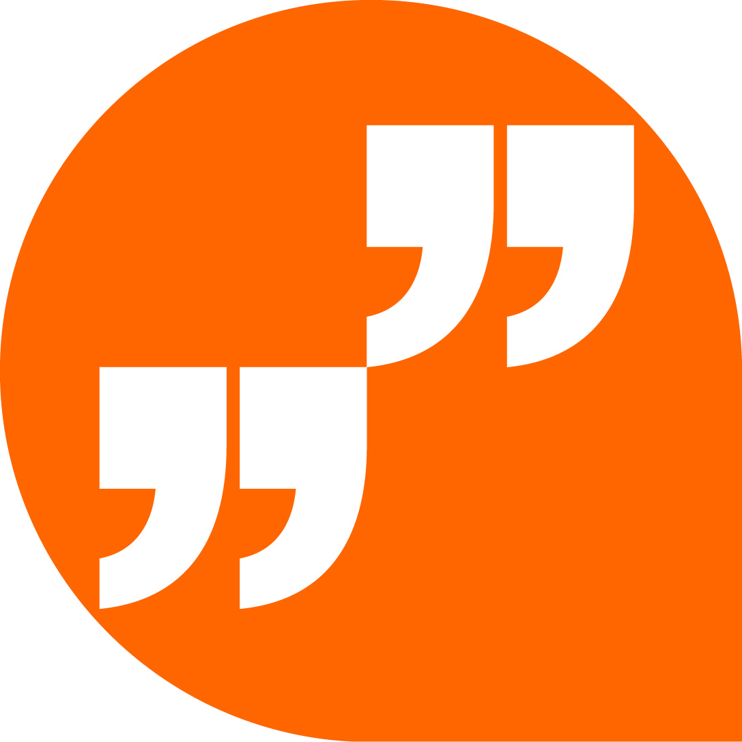 | LiveChat with our technical team at igus.co.uk
 | Follow us at twitter.com/igusUK
 | Watch our videos at igus.co.uk/YouTube
 | Connect to us at igus.co.uk/Facebook
 | Read our blog at blog.igus.co.uk

About igus:
Based in Northampton in the UK and with global headquarters in Cologne, Germany, igus is a leading international manufacturer of energy chain systems and polymer plain bearings. The family-run company is represented in 35 countries and employs 4,150 people around the world. In 2018, igus generated a turnover of 748 million euros with motion plastics, plastic components for moving applications.

With plastic bearing experience since 1964, cable carrier experience since 1971 and continuous-flex cable experience since 1989, igus provides the right solution based on 100,000 products available from stock, with between 1,500 and 2,500 new product introductions each year. igus operates the largest test laboratories and factories in its sector to offer customers quick turnaround times on innovative products and solutions tailored to their needs.

The terms igus, Apiro, chainflex, CFRIP, conprotect, CTD, drylin, dry-tech, dryspin, easy chain, e-chain, e-chain systems, e-ketten, e-kettensysteme, e-skin, flizz, ibow, igear, iglidur, igubal, kineKIT, manus, motion plastics, pikchain, plastics for longer life, readychain, readycable, ReBeL, speedigus, triflex, robolink, and xiros are protected by trademark laws in the Federal Republic of Germany and internationally, where applicable.

All other registered trademarks and trademarks are the property of their respective owners.

For further information, please contact:
Megan Campbell, igus
Tel: 01604 677240
Email: mcampbell@igus.co.uk

Dulcie Elliot, Publitek
Tel: 01582 390980
Email: dulcie.elliot@publitek.com

