Video of the Week – Why choose igus’ motion plastics for medical applications?

Whether in handling applications or in laboratory equipment, where there is movement, energy chains are widely used to protect and guide cables and hoses. In the medical industry, however, higher demands are placed on the components, which must all run very smoothly and quietly, be cleanroom-compatible, media-resistant and corrosion-free and of hygienic design. In this week’s video, igus introduces a selection of the energy chains and cables, iglidur plain bearings and drylin delta robots developed specifically for medical technology.

The e-skin energy chain system provides cleanroom equipment with data, power and media without unwanted particles contaminating the air, as proven by the Fraunhofer Institute IPA. All three e-skin energy chain types, with and without cables, have ISO Class 1 certification, which is the ‘cleanest’ classification.

The CFROBOT8.PLUS bus cable is constructed specifically for high torsion applications, including robots and equipment with 3D movements. Supporting clean, medical applications, its PUR outer jacket is abrasion- and microbe-resistant.

The E2.1 energy chain series offers extremely fast filling from the side or from the top – along on the inner or outer radius, using a chain opening tool or screwdriver. Thanks to these features, its compact size and quiet operation, the E2.1 is ideal for use in medical equipment, such as scanners.

For rotating applications, the compact iglidur PRT-04 slewing ring features an aluminium housing for easy cleaning, and sliding elements made from iglidur J. The iglidur J material has a low coefficient of friction in dry operation and very low stick-slip effect for smooth movements.

To watch the video and find out which other igus products are being used in medical technology, please follow this link: youtu.be/EeYKFEUkryE

For further reading about how igus meets medical technology requirements, please visit: www.igus.co.uk/info/industries-medical-industry or call igus directly on: 01604 677240

igus resources:
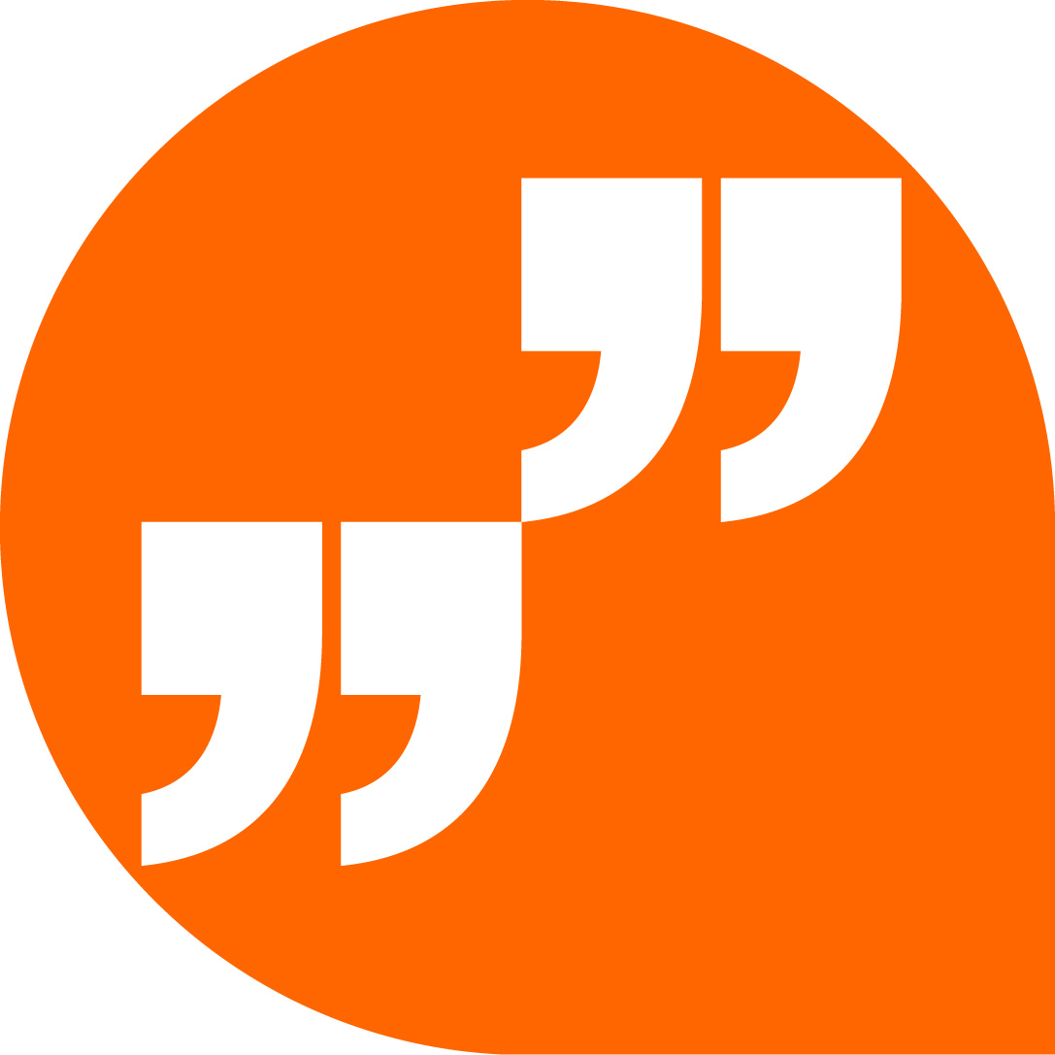 | LiveChat with our technical team at igus.co.uk
 | Follow us at twitter.com/igusUK
 | Watch our videos at igus.co.uk/YouTube
 | Connect to us at igus.co.uk/Facebook
 | Read our blog at blog.igus.co.uk

About igus:
Based in Northampton in the UK and with global headquarters in Cologne, Germany, igus is a leading international manufacturer of energy chain systems and polymer plain bearings. The family-run company is represented in 35 countries and employs 4,150 people around the world. In 2018, igus generated a turnover of 748 million euros with motion plastics, plastic components for moving applications.

With plastic bearing experience since 1964, cable carrier experience since 1971 and continuous-flex cable experience since 1989, igus provides the right solution based on 100,000 products available from stock, with between 1,500 and 2,500 new product introductions each year. igus operates the largest test laboratories and factories in its sector to offer customers quick turnaround times on innovative products and solutions tailored to their needs.

The terms igus, Apiro, chainflex, CFRIP, conprotect, CTD, drylin, dry-tech, dryspin, easy chain, e-chain, e-chain systems, e-ketten, e-kettensysteme, e-skin, flizz, ibow, igear, iglidur, igubal, kineKIT, manus, motion plastics, pikchain, plastics for longer life, readychain, readycable, ReBeL, speedigus, triflex, robolink, and xiros are protected by trademark laws in the Federal Republic of Germany and internationally, where applicable.

All other registered trademarks and trademarks are the property of their respective owners.

For further information, please contact:
Megan Campbell, igus
Tel: 01604 677240
Email: mcampbell@igus.co.uk

Dulcie Elliot, Publitek
Tel: 01582 390980
Email: dulcie.elliot@publitek.com

