e-spool flex cable reel with spiral guide ensures more safety for control pendants and assembly areas

The new e-spool flex from igus moves a single cable or hose safely and stows it away quickly whilst retaining an end-to-end connection. This increases safety at manual workstations and on control pendants. The spiral guide allows quick installation of the cable into the reel and the e-spool flex is ready for use.

To use tools and control pendants flexibly in production, they require appropriately long cables and hoses. However, these are often strewn across the floor unprotected and can create a trip hazard. Cable reels with slip rings offer a solution for power transmission but are often only available as a complete package with a custom cable. A further disadvantage is that the fast transmission of data and media can be difficult with slip rings. Therefore, igus has developed the e-spool flex cable reel, which uses a spiral guide instead.

The new cable reel will guide a power or data cable or a hose for air and liquids without interruption to the connection. The user can also install an existing cable or hose in the system, which saves on cost. Simply insert the cable or hose into the spiral guide for fast assembly. The guide is then inserted into the outer housing of the e-spool flex. This means that the cable can move freely in use and is quickly and cleanly stowed away afterwards.

The e-spool flex is available in two versions: a low-cost system with manual winder or an automatic solution with a brake and a spring-driven return mechanism. The e-spool flex is available in three sizes for cables with a diameter of 5 to 11mm and an extension length of 5 to 15m. The cables can be quickly replaced at any time. In addition to using the e-spool flex with an existing cable, igus also offers the cable reel solution fully harnessed with chainflex cables designed specifically for moving applications – all of which come with a 36-month guarantee.

For more information about the e-spool flex, please visit: www.igus.co.uk/info/e-spool-flex or call igus directly on: 01604 677240.

igus resources:
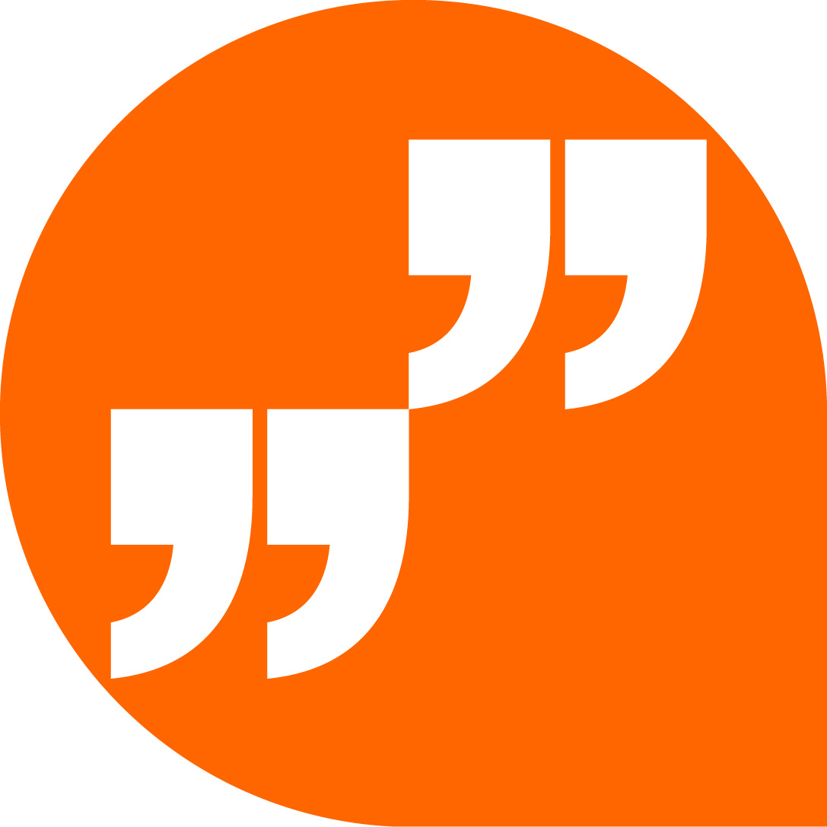 | LiveChat with our technical team at igus.co.uk
 | Follow us at twitter.com/igusUK
 | Watch our videos at igus.co.uk/YouTube
 | Connect to us at igus.co.uk/Facebook
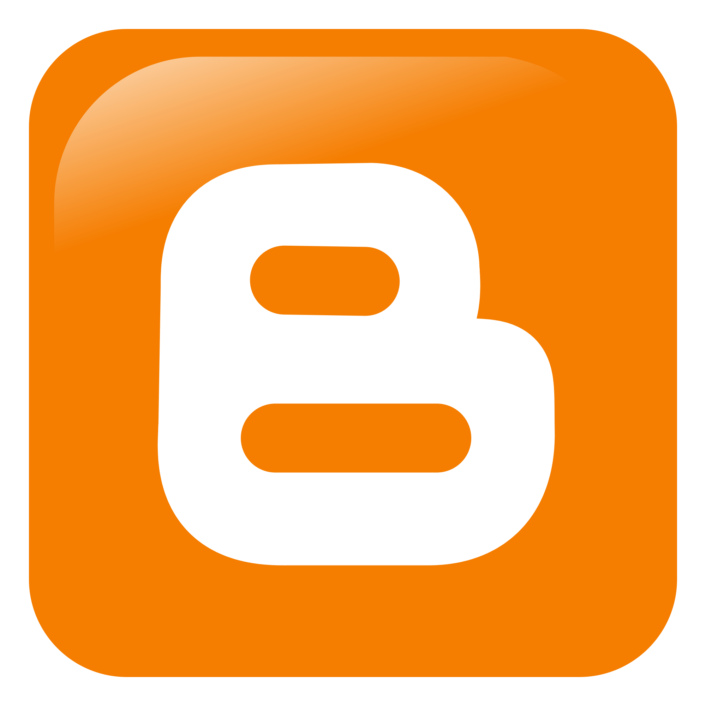 | Read our blog at blog.igus.co.uk

About igus:
Based in Northampton in the UK and with global headquarters in Cologne, Germany, igus is a leading international manufacturer of energy chain systems and polymer plain bearings. The family-run company is represented in 35 countries and employs 4,150 people around the world. In 2019, igus generated a turnover of 764 million euros with motion plastics, plastic components for moving applications.

With plastic bearing experience since 1964, cable carrier experience since 1971 and continuous-flex cable experience since 1989, igus provides the right solution based on 100,000 products available from stock, with between 1,500 and 2,500 new product introductions each year. igus operates the largest test laboratories and factories in its sector to offer customers quick turnaround times on innovative products and solutions tailored to their needs.

The terms igus, Apiro, chainflex, CFRIP, conprotect, CTD, drylin, dry-tech, dryspin, easy chain, e-chain, e-chain systems, e-ketten, e-kettensysteme, e-skin, flizz, ibow, igear, iglidur, igubal, kineKIT, manus, motion plastics, pikchain, plastics for longer life, readychain, readycable, ReBeL, speedigus, triflex, robolink, and xiros are protected by trademark laws in the Federal Republic of Germany and internationally, where applicable.

All other registered trademarks and trademarks are the property of their respective owners.

For further information, please contact:
Megan Campbell, igus
Tel: 01604 677240
Email: mcampbell@igus.co.uk

Dulcie Elliot, Publitek
Tel: 01582 390980
Email: dulcie.elliot@publitek.com

