Fast entry into low-cost automation using a digital twin in intuitive robot control

igus has developed control software for its low-cost automation solutions that allows users to easily program their robots. Available online, free of charge, the igus robot control software enables different robot kinematics to be programmed and controlled. A digital twin simulates the movements, allowing the user to program a suitable solution before purchase.

Picking up goods from a box, helping to take samples and dispensing items from a machine can all done by robots. Whether it is articulated robolink robot arms, drylin delta robots or drylin linear robots, users can try out in advance which robot is best suited for their application.

“As a mechanical engineering company, we are very familiar with the different kinematics, so the next logical step for us was to develop a correspondingly simple and intuitive robot control system,” says Robert Dumayne, dry-tech director, igus. “The software is available online free of charge and is licence-free.”

In the software there is a digital twin for all igus robots, which can be simulated and taught like a real robot. Matching end effectors, such as grippers, are easy to add and the tool centre point adjusts automatically. Virtual boxes can also be installed, for example, to prevent the robot from colliding with a machine. The igus robot control can also be connected to a higher-level control system, either via interface communication with Digital IO or via Ethernet communication using an IP address. Every program can be applied to the real robot afterwards.

For more information about igus’ Robot Control system, please visit: www.igus.co.uk/info/robot-control-system or call igus directly on: 01604 677240.

igus resources:
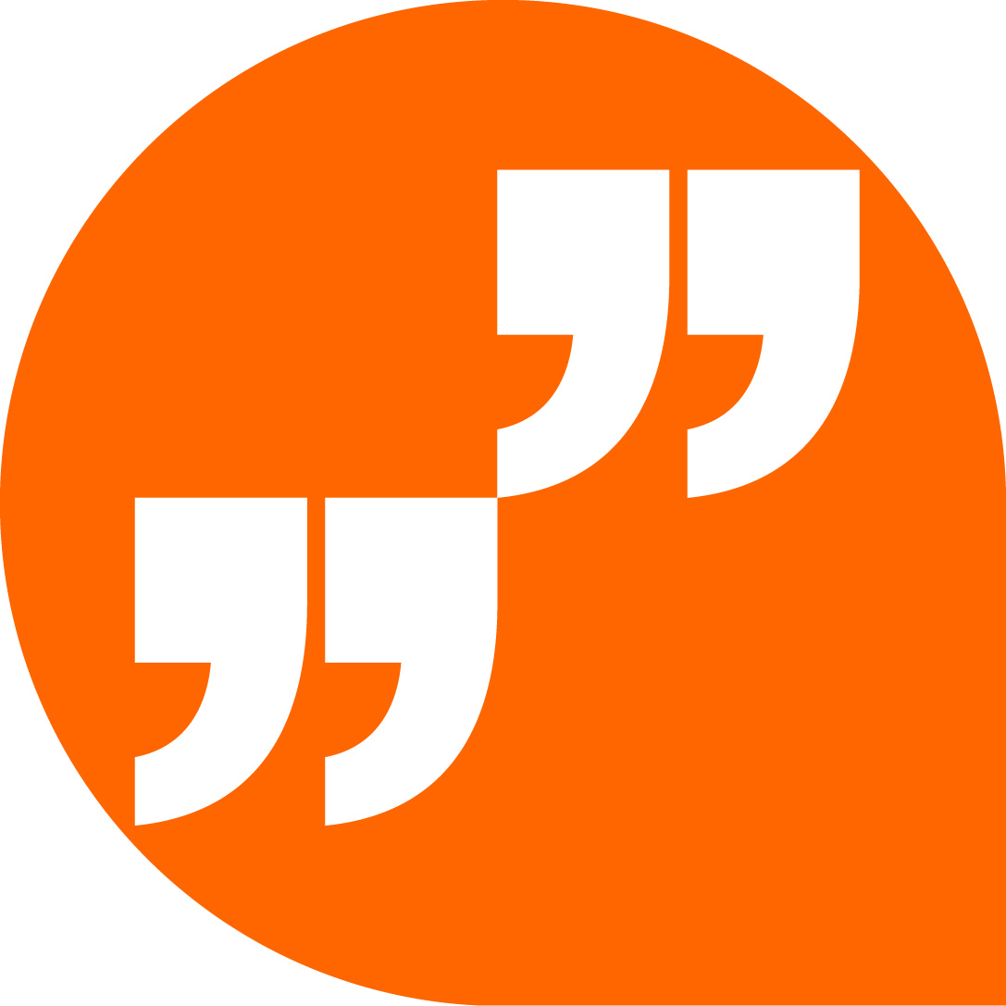 | LiveChat with our technical team at igus.co.uk
 | Follow us at twitter.com/igusUK
 | Watch our videos at igus.co.uk/YouTube
 | Connect to us at igus.co.uk/Facebook
 | Read our blog at blog.igus.co.uk

About igus:
Based in Northampton in the UK and with global headquarters in Cologne, Germany, igus is a leading international manufacturer of energy chain systems and polymer plain bearings. The family-run company is represented in 35 countries and employs 4,150 people around the world. In 2019, igus generated a turnover of 764 million euros with motion plastics, plastic components for moving applications.

With plastic bearing experience since 1964, cable carrier experience since 1971 and continuous-flex cable experience since 1989, igus provides the right solution based on 100,000 products available from stock, with between 1,500 and 2,500 new product introductions each year. igus operates the largest test laboratories and factories in its sector to offer customers quick turnaround times on innovative products and solutions tailored to their needs.

The terms igus, Apiro, chainflex, CFRIP, conprotect, CTD, drylin, dry-tech, dryspin, easy chain, e-chain, e-chain systems, e-ketten, e-kettensysteme, e-skin, flizz, ibow, igear, iglidur, igubal, kineKIT, manus, motion plastics, pikchain, plastics for longer life, readychain, readycable, ReBeL, speedigus, triflex, robolink, and xiros are protected by trademark laws in the Federal Republic of Germany and internationally, where applicable.

All other registered trademarks and trademarks are the property of their respective owners.

For further information, please contact:
Megan Campbell, igus
Tel: 01604 677240
Email: mcampbell.ext@igus.co.uk

Dulcie Elliot, Publitek
Tel: 01582 390980
Email: dulcie.elliot@publitek.com

