Güdel linear robot, even more productive with intelligent energy supply
igus energy chain sensors, monitors movement and measures wear

Plan maintenance in advance: the igus intelligent smart plastic e-chains, cables, and plain bearings can assist with this. Now, manufacturers of machines and systems are also offering solutions with their own condition monitoring. Among them is the Swiss company Güdel: the automation specialist uses the igus e-chain sensors EC.M and EC.W in their linear robots. "The sensors measure the movement and wear of the four energy chains used and send the measured values via the icom data collector to Güdel's condition monitoring computer", explains Richard Habering, head of the smart plastics division at igus. By connecting to the igus cloud, the data is evaluated using AI and machine learning. The integration of the analysed data takes place via the Güdel Condition Monitoring System. "With this tool, the user can monitor the status of the energy chains and rollers in use", says Daniel Bangerter, head of customer care at Güdel. "Maintenance can be planned by collecting and evaluating the data."

For further information on igus smart plastics and preventative maintenance visit www.igus.co.uk/smartplastics

Picture caption; igus smart plastics giving intelligent and comprehensive results.
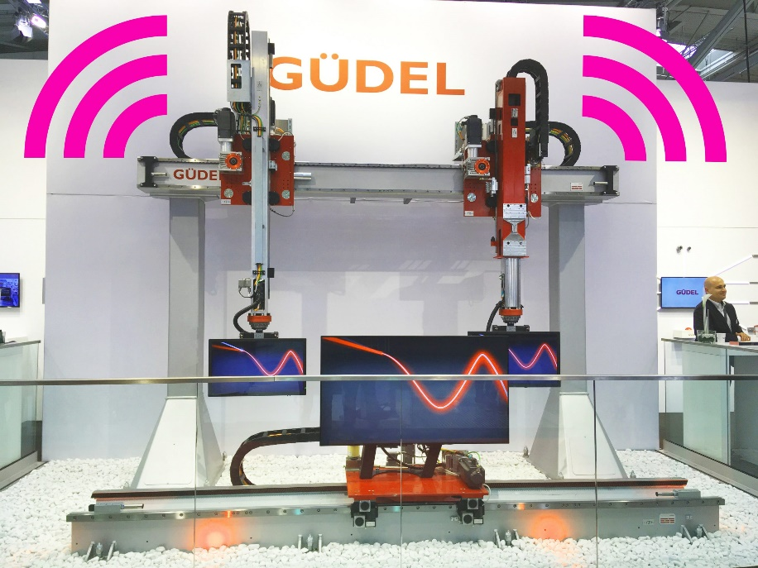
igus resources:
LiveChat with our technical team at igus.co.uk
Follow us at twitter.com/igusUK
Watch our videos at igus.co.uk/YouTube
Connect to us at igus.co.uk/Facebook
Read our blog at blog.igus.co.uk

About igus:

Based in Northampton in the UK and with global headquarters in Cologne, Germany, igus is a leading international manufacturer of energy chain systems and polymer plain bearings. The family-run company is represented in 35 countries and employs over 4000 people around the world. In 2019, igus generated a turnover of 764 million euros with motion plastics, plastic components for moving applications.

With plastic bearing experience since 1964, cable carrier experience since 1971 and continuous-flex cable experience since 1989, igus provides the right solution based on 100,000 products available from stock, with between 1,500 and 2,500 new product introductions each year. igus operates the largest test laboratories and factories in its sector to offer customers quick turnaround times on innovative products and solutions tailored to their needs.

For further information, please contact:

Erin Kemal
Tel: 01604 677240
Email: ekemal@igus.co.uk

Hannah Durrant
Tel: 01604 677240
Email: hdurrant@igus.co.uk

The terms "igus", “Apiro”, "chainflex", "CFRIP", "conprotect", "CTD", "drylin", "dry-tech", "dryspin", "easy chain", "e-chain", "e-chain systems", "e-ketten", "e-kettensysteme", "e-skin", "e-spool”, "flizz", “ibow”, “igear”, "iglidur", "igubal", “kineKIT”, "manus", "motion plastics", "pikchain", "plastics for longer life", "readychain", "readycable", “ReBeL”, "speedigus", "triflex", "robolink", “xirodur”, and "xiros" are protected by trademark laws in the Federal Republic of Germany and internationally, where applicable.

