**Harnessed readycable for e-chains transmits energy and data securely in a compact installation space**

**In order to supply modern motors with energy and data, users need appropriate cables that function reliably, even at high accelerations and on long travels. Especially for dynamic use, igus has now developed a hybrid cable that is offered as a drive solution for the new Bosch Rexroth motors. It combines an energy and data cable in one and is therefore also ideal for compact installation spaces. igus also offers the cable as a fully harnessed readycable.**

The trend to have smaller and more compact machinery? with an even higher output is becoming increasingly apparent in the field of motor development. Not only the motor, but also the cables used, must meet these new requirements. Hybrid cables are one solution as they combine energy and data supply in one, by integrating the encoder cable into the servo cable. This eliminates the need for cabling with a separate measuring system for the encoder. Designed specifically for use in energy chains, igus has now developed a new [hybrid cable](https://www.igus.eu/product/20291) suitable for Bosch Rexroth MS2N and IndraDrive Mi motors. A halogen-free PUR outer jacket ensures oil resistance and increases the service life of the cable. The user receives the drive solution already fully harnessed with connector, this is known as an igus readycable. "While other manufacturers on the market only offer cables in metre lengths, customers can order their solutions from us down to the centimetre. This way we avoid unnecessary waste or residual stock. As readycables, the cable can be connected directly to the machine. This saves additional harnessing and installation time", explains James Harrison, readycable Product Manager at igus UK.

**readycable finder helps in product selection**

All cables are tested and inspected under real conditions in the company's own 3,800 square metre test laboratory. Tests have shown that the new hybrid cable with a bend radius of up to 10xd in the e-chain can safely withstand 10 million double strokes over the long term. Due to the realistic tests, igus is the only cable manufacturer in the world capable of providing a 36-month guarantee on its chainflex cables. In total, igus has over 4,200 drive cables suitable for 24 manufacturer standards in its readycable range. For a quick selection of the suitable solution, with the [readycable product finder](https://www.igus.eu/readycableproductfinder/search) (put in UK link) igus offers a practical online tool. Simply enter the igus part number, the manufacturer or select the name of the drive manufacturer from the menu; then click on the required cable type and the product finder will list all matching parts. An overview provides the different cable qualities such as outer jacket, bend radius, travel and price. The integrated service life calculator also determines the running time. One click is all it takes to order the matching cable in the desired length and have it shipped within 24 hours.

**Caption:**

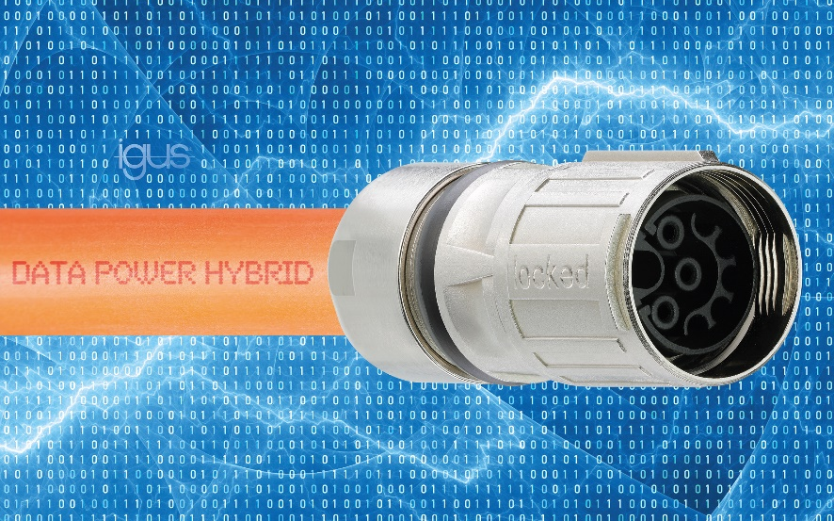

**Picture PM2020-1**

More compact with higher output: the new hybrid cables.

**igus resources:**

|  |  |
| --- | --- |
|  | LiveChat with our technical team at [igus.co.uk](http://www.igus.co.uk) |
| social icons | Follow us at [twitter.com/igusUK](https://twitter.com/igusUK) |
| Icon for web | Watch our videos at [igus.co.uk/YouTube](https://www.youtube.com/igusuk) |
| social icons | Connect to us at [igus.co.uk/Facebook](https://www.facebook.com/igus.co.uk) |
| blogger logo | Read our blog at [blog.igus.co.uk](https://blog.igus.co.uk) |

**About igus:**

Based in Northampton in the UK and with global headquarters in Cologne, Germany, igus is a leading international manufacturer of energy chain systems and polymer plain bearings. The family-run company is represented in 35 countries and employs over 4000 people around the world. In 2019, igus generated a turnover of 764 million euros with motion plastics, plastic components for moving applications.

With plastic bearing experience since 1964, cable carrier experience since 1971 and continuous-flex cable experience since 1989, igus provides the right solution based on 100,000 products available from stock, with between 1,500 and 2,500 new product introductions each year. igus operates the largest test laboratories and factories in its sector to offer customers quick turnaround times on innovative products and solutions tailored to their needs.

**For further information, please contact:**

Erin Kemal

Tel: 01604 677240

Email: [ekemal@igus.co.uk](mailto:ekemal@igus.co.uk)

Hannah Durrant

Tel: 01604 677240

Email: [hdurrant@igus.co.uk](mailto:hdurrant@igus.co.uk)

The terms "igus", “Apiro”, "chainflex", "CFRIP", "conprotect", "CTD", "drylin", "dry-tech", "dryspin", "easy chain", "e-chain", "e-chain systems", "e-ketten", "e-kettensysteme", "e-skin", "e-spool”, "flizz", “ibow”, “igear”, "iglidur", "igubal", “kineKIT”, "manus", "motion plastics", "pikchain", "plastics for longer life", "readychain", "readycable", “ReBeL”, "speedigus", "triflex", "robolink", “xirodur”, and "xiros" are protected by trademark laws in the Federal Republic of Germany and internationally, where applicable.