A winning combination: the new linear and pivoting slide from igus
A drylin W linear guide fitted with a PRT slewing ring bearing provides linear and rotating motion.

This new design study from igus can move linearly and rotate simultaneously. With the drylin W linear/pivot guide, armrests, trays and control panels on seats and armchairs, for example, can be easily adjusted to suit the user. What previously had to be painstakingly put together by the customer, is now available as a complete assembly. In addition, the lubrication-free polymer sliding elements ensures quiet movements.

Popcorn, sweets, soft drinks and a comfortable armchair, for many people these are associated with a cinema experience. To make a visit to the cinema even more dramatic, some theatres are fitting seats with additional technological features. Examples of this can be seen on extendable tables, or on trays in the armrests of furniture. igus has developed this new product especially for use in multifunctional armchairs and seats: the drylin W linear/pivot guide. This unique system allows users to move trays or displays forwards and backwards linearly as well as to rotate. "In addition to cinema, theatre and aircraft seats, the new drylin W guide is intended for applications in control cabins, such as in tractors or even cranes. “Wherever operating elements require movement, flexibly and ergonomically in a compact space", explains Lee Wilkins, igus drylin Product Manager in the UK. For the new development, igus simply combined two already existing and successfully proven products: a drylin W linear guide for linear motion with a PRT-04 slewing ring bearing for rotation. The slewing ring bearing is then integrated in the carriage plate. This previously meant that both products had to be installed together, the carriage plate had to be machined to accommodate the slewing ring and the cable fed through. Now, thanks to the ready-to-install complete system, the customer saves time and money in manufacture.

Quiet adjustment
Instead of ball guides, igus uses tribologically optimised high-performance polymers in the sliding elements of the linear carriage and the bearing. They are up to four times quieter than ball guides whilst at the same time, lubrication-free and maintenance-free. By eliminating additional lubricants and oils, the drylin W linear/pivot guide is insensitive to dust and dirt. Cleanliness is a major advantage of the guide. "In addition to the practical functionality of our new product, we naturally also attached great importance to the design. Lightweight materials such as plastic and aluminium are used and we use a decorative clear anodised coating for the rails", says Lee Wilkins. At 40mm height, the new design study is a very low-profile system and can also be equipped with a manual clamp or individual pretension. This allows the display to stay in place after adjustment.

Caption: one complete system for rotational and linear movement.

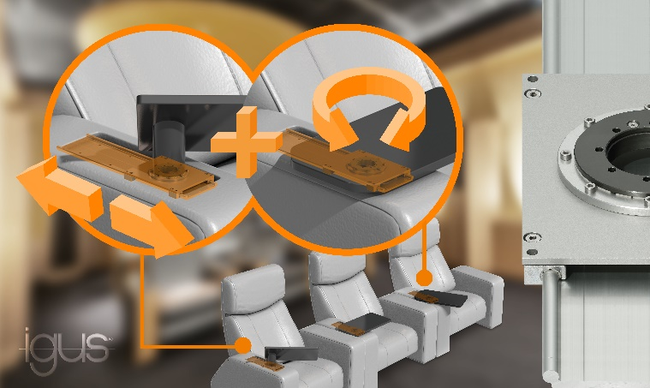

igus resources:
LiveChat with our technical team at igus.co.uk
Follow us at twitter.com/igusUK
Watch our videos at igus.co.uk/YouTube
Connect to us at igus.co.uk/Facebook
Read our blog at blog.igus.co.uk

About igus:

Based in Northampton in the UK and with global headquarters in Cologne, Germany, igus is a leading international manufacturer of energy chain systems and polymer plain bearings. The family-run company is represented in 35 countries and employs over 4000 people around the world. In 2019, igus generated a turnover of 764 million euros with motion plastics, plastic components for moving applications.

With plastic bearing experience since 1964, cable carrier experience since 1971 and continuous-flex cable experience since 1989, igus provides the right solution based on 100,000 products available from stock, with between 1,500 and 2,500 new product introductions each year. igus operates the largest test laboratories and factories in its sector to offer customers quick turnaround times on innovative products and solutions tailored to their needs.

For further information, please contact:

Erin Kemal
Tel: 01604 677240
Email: ekemal@igus.co.uk

Hannah Durrant
Tel: 01604 677240
Email: hdurrant@igus.co.uk

The terms "igus", “Apiro”, "chainflex", "CFRIP", "conprotect", "CTD", "drylin", "dry-tech", "dryspin", "easy chain", "e-chain", "e-chain systems", "e-ketten", "e-kettensysteme", "e-skin", "e-spool”, "flizz", “ibow”, “igear”, "iglidur", "igubal", “kineKIT”, "manus", "motion plastics", "pikchain", "plastics for longer life", "readychain", "readycable", “ReBeL”, "speedigus", "triflex", "robolink", “xirodur”, and "xiros" are protected by trademark laws in the Federal Republic of Germany and internationally, where applicable.

