igus 3D printing service: low-wear polymer parts in 5 days!
Production-ready, long-lasting special parts from a 3D printer, increase design freedom in the automotive industry

Additive manufacturing gives designers new freedom and flexibility in the design of special solutions, including the development of efficient vehicle components. If lightweight and durable wear-resistant parts are required, igus offers a solution from their 3D printing service. Users can order a special part made of tribologically- optimised polymers from igus online in just a few seconds.

A quick response time and customised design are paramount in the automotive industry design teams. The industry needs partners who can deliver special solutions in small quantities, cost-effectively, fast, and by responding to new requirements to create a competitive advantage in the automotive market. The expanded 3D printing service from igus is particularly suitable for the short-term production of wear-resistant parts. The motion plastics specialist uses 3D printing to cost-effectively produce prototypes or batches within a very short time. The main advantage of additive manufacturing: the designer has maximum freedom in the design of the component, without having to invest in expensive steel tools with long lead times. igus manufactures the solutions from their highly wear-resistant iglidur tribo-polymers. Tests in the igus laboratory show that they are up to 50 times more abrasion-resistant than standard polymers and are comparable to injection moulded parts in terms of wear resistance. They are both lightweight and quiet in motion - important criteria in vehicle design. Printed solutions from igus are already being used in turbochargers, as pivoting bearings in suspension systems and for a special accelerator mechanism.

print2mold process ensures the free choice of materials
In the igus 3D printing service, the user can choose between different manufacturing processes: they can either manufacture their component using the laser sintering process, with iglidur I3, iglidur I6 and I8 ESD tribo-polymers or alternatively using twelve different filaments using the FDM process. For the individual component to be made from the ideal iglidur material for the respective application, igus also offers the print2mold process. An injection moulding tool is printed for the special solution and is then used in the injection moulding machine. This allows the designer to make use of the total iglidur material range of 55 tribo-polymers.

Wear-resistant components requested online
The way to a lubrication-free special solution is very simple: click on the link https://iglidur-designer.igus.tools/upload, upload the STEP file of the component and select the appropriate material. The price for production (in the print2mold process including the costs for the injection moulding tool) as well as information about the material, precision and flexural strength are shown online. After selecting the appropriate tribo-polymer, the user can enter the quantity and request either a quotation or order the parts. The additively manufactured special parts are shipped 5 days after the order has been placed. In the case of the print2mold process, the injection-moulded parts are ready for shipping approximately 10 business days after the order has been confirmed.

Caption: wear-resistant parts with complex geometries made of tribo-polymers

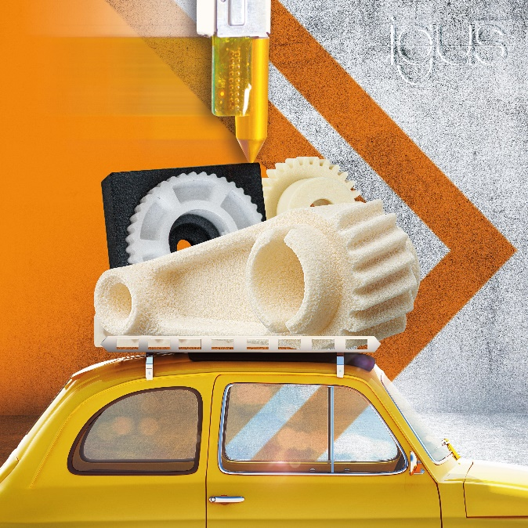

igus resources:
LiveChat with our technical team at igus.co.uk
Follow us at twitter.com/igusUK
Watch our videos at igus.co.uk/YouTube
Connect to us at igus.co.uk/Facebook
Read our blog at blog.igus.co.uk

About igus:

Based in Northampton in the UK and with global headquarters in Cologne, Germany, igus is a leading international manufacturer of energy chain systems and polymer plain bearings. The family-run company is represented in 35 countries and employs over 4000 people around the world. In 2019, igus generated a turnover of 764 million euros with motion plastics, plastic components for moving applications.

With plastic bearing experience since 1964, cable carrier experience since 1971 and continuous-flex cable experience since 1989, igus provides the right solution based on 100,000 products available from stock, with between 1,500 and 2,500 new product introductions each year. igus operates the largest test laboratories and factories in its sector to offer customers quick turnaround times on innovative products and solutions tailored to their needs.

For further information, please contact:

Erin Kemal
Tel: 01604 677240
Email: ekemal@igus.co.uk

Hannah Durrant
Tel: 01604 677240
Email: hdurrant@igus.co.uk

The terms "igus", “Apiro”, "chainflex", "CFRIP", "conprotect", "CTD", "drylin", "dry-tech", "dryspin", "easy chain", "e-chain", "e-chain systems", "e-ketten", "e-kettensysteme", "e-skin", "e-spool”, "flizz", “ibow”, “igear”, "iglidur", "igubal", “kineKIT”, "manus", "motion plastics", "pikchain", "plastics for longer life", "readychain", "readycable", “ReBeL”, "speedigus", "triflex", "robolink", “xirodur”, and "xiros" are protected by trademark laws in the Federal Republic of Germany and internationally, where applicable.

