PRESS RELEASE
September3 2020

Fast and lubrication-free: new xiros film guide roller for labelling technology

A new black coloured guide roller with smooth-running polymer ball bearings has been designed and manufactured – following a customer request and extensive testing by the team at igus.
The product, which uses black anodised aluminium tubes, is the latest in the xiros film guide roller range, largely used in the fields of packaging and food technology.
igus, whose UK headquarters are in Northampton, are motion plastic experts and a global manufacturer of energy chain systems and polymer plain bearings.
Matthew Aldridge, Managing Director, igus UK, said: “As with any of our igus products, the idea for this new design was put forward, prototypes were designed and after extensive testing, the results were positive and showed nothing detrimental in comparison to the original clear anodised aluminium roller. A new product was born.
"The idea for the black design arose from a customer enquiry. The technical specifications of our classic aluminium rollers were already very convincing, but black visible parts were desired for this labelling machine.
"This soon resulted in a product that met the customer's requirements – not just in terms of technology but also in price and appearance. The new black roller, since it does not reflect light, has the added benefit of working smoothly with vision systems.”
Fully assembled, the xiros standard roller systems include a tube made of aluminium, carbon, or PVC, which is then fitted with xiros bearings. These xiros polymer ball bearings are lubrication-free, maintenance-free, hygienic and have a low breakaway torque. The complete system acts as a guide roller for deflecting films and labels or for conveying goods.
By using wear-resistant high-performance polymers and thin-walled tubes, they provide a weight saving of up to 48 per cent compared to metallic solutions.
Their mass inertia is 42 per cent lower, and therefore the energy required for acceleration is considerably lower. This means the rollers can reach the conveyor speed faster.

Custom guide
Find out what specification you need: Go online and specify the outer and inner diameter you require, as well as the length of the roller, the load, speed, and the ambient temperature.
You will also need to enter the acting force and the degree of wrap around. The online igus calculator will then suggest the appropriate tube materials.
In the second step, stay online and select the guide roller based on the deflection, weight, and price data, download the configuration CAD data, and order the xiros rollers directly online.
end

Picture captions
- Picture PM2820-1: Easy and lubrication-free guidance of labels with xiros polymer ball bearings in the new black guide roller
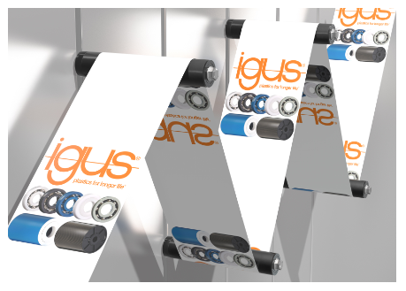

igus resources:
LiveChat with our technical team at igus.co.uk
Follow us at twitter.com/igusUK
Watch our videos at igus.co.uk/YouTube
Connect to us at igus.co.uk/Facebook
Read our blog at blog.igus.co.uk

About igus:

Based in Northampton in the UK and with global headquarters in Cologne, Germany, igus is a leading international manufacturer of energy chain systems and polymer plain bearings. The family-run company is represented in 35 countries and employs over 4000 people around the world. In 2019, igus generated a turnover of 764 million euros with motion plastics, plastic components for moving applications.

With plastic bearing experience since 1964, cable carrier experience since 1971 and continuous-flex cable experience since 1989, igus provides the right solution based on 100,000 products available from stock, with between 1,500 and 2,500 new product introductions each year. igus operates the largest test laboratories and factories in its sector to offer customers quick turnaround times on innovative products and solutions tailored to their needs.

For further information, please contact:

Erin Kemal
Tel: 01604 677240
Email: ekemal@igus.co.uk

Hannah Durrant
Tel: 01604 677240
Email: hdurrant@igus.co.uk

The terms "igus", “Apiro”, "chainflex", "CFRIP", "conprotect", "CTD", "drylin", "dry-tech", "dryspin", "easy chain", "e-chain", "e-chain systems", "e-ketten", "e-kettensysteme", "e-skin", "e-spool”, "flizz", “ibow”, “igear”, "iglidur", "igubal", “kineKIT”, "manus", "motion plastics", "pikchain", "plastics for longer life", "readychain", "readycable", “ReBeL”, "speedigus", "triflex", "robolink", “xirodur”, and "xiros" are protected by trademark laws in the Federal Republic of Germany and internationally, where applicable.

