Ref UKEK500
PRESS RELEASE

Digital engineering support during a pandemic: Thousands visit igus trade exhibition

An online trade show created by motion plastics specialists igus has attracted more than 10,000 customers since its launch in May.

The company, which has its UK headquarters in Northampton, has launched more than 120 innovative products in the last seven months from its 400 square metre stand at the company’s headquarters in Cologne, Germany.

Matthew Aldridge, UK Managing Director of igus, the global manufacturer of energy chain systems and polymer plain bearings, has held several meetings with UK customers at the online trade show.

Matthew said: “At these meetings I usually invite a product expert from Cologne to join us, who acts as our eyes on the stand and takes us on a tour. Although we prefer face to face contact this digital alternative has proved popular and effective and since its launch, we have welcomed more than 10,000 people from all over the world to our igus trade exhibition.

“When the pandemic saw one trade show after another being cancelled it quickly became clear we needed to act fast and design an alternative that would look and feel as close to a real-life exhibition as possible.

“This online trade show is now a key part of the digital support we offer our customers, many of whom hold their own one-to-one and group meetings during their visit.”

A trade show stand in motion
This igus online exhibition, themed ‘Cost down, Life up, It’s our job’ showcases everything from low cost automation robots to plain bearing technology and the igus ‘autoglide 5 system’, which guides cables and hoses safely, for long distances and at a low cost.

It is home to press conferences, product launches and to the vector award 2020, which honours inspiring energy solutions and e-chain systems with cables.

There are also online seminars, where customers can find out about the latest developments in tribo-polymers – everything from materials and project planning to assembly aids, recycling and how to build a 3D printer.

Delegates keen to see products for themselves are invited to request product samples after their trade stand visit.

An igus customer commented: "At a typical exhibition I usually have to wait my turn but at this trade show it is easy and fast to book appointments, and the product tour is customised and concise.”

In addition to the 10,000 plus customer appointments, over 53,000 additional visitors have strolled through the virtual version of the igus stand, which is an online version of this exhibition.

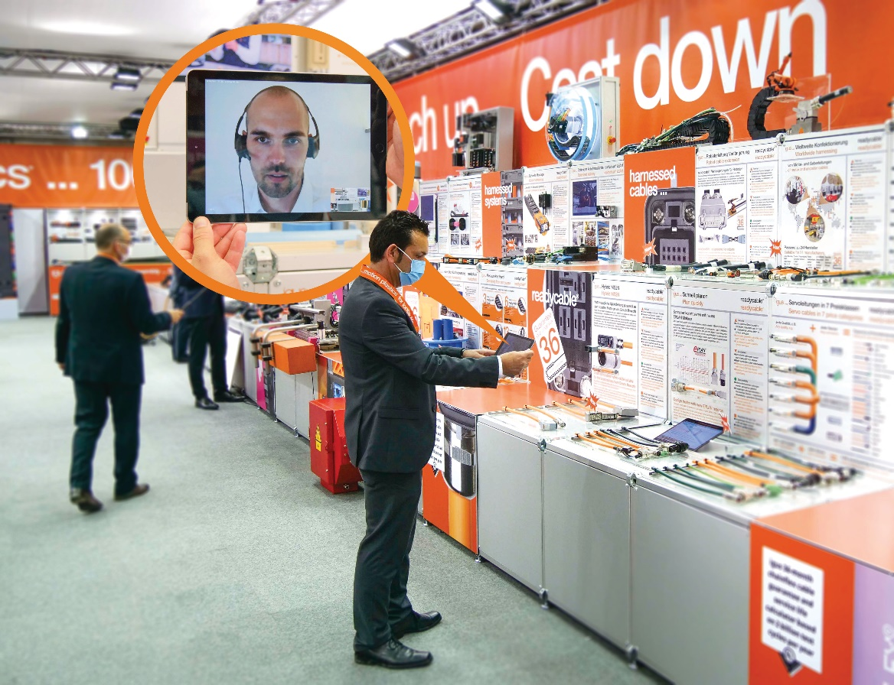
Picture UKEK500_1
The igus exhibition stand can be explored virtually, on your own or together with a consultant. (Source: igus)

About igus:

Based in Northampton in the UK and with global headquarters in Cologne, Germany, igus is a leading international manufacturer of energy chain systems and polymer plain bearings. The family-run company is represented in 35 countries and employs over 4000 people around the world. In 2019, igus generated a turnover of 764 million euros with motion plastics, plastic components for moving applications.

With plastic bearing experience since 1964, cable carrier experience since 1971 and continuous-flex cable experience since 1989, igus provides the right solution based on 100,000 products available from stock, with between 1,500 and 2,500 new product introductions each year. igus operates the largest test laboratories and factories in its sector to offer customers quick turnaround times on innovative products and solutions tailored to their needs.

For further information, please contact:

Erin Kemal
Tel: 01604 677240
Email: ekemal@igus.co.uk

Hannah Durrant
Tel: 01604 677240
Email: hdurrant@igus.co.uk

The terms "igus", “Apiro”, "chainflex", "CFRIP", "conprotect", "CTD", "drylin", "dry-tech", "dryspin", "easy chain", "e-chain", "e-chain systems", "e-ketten", "e-kettensysteme", "e-skin", "e-spool”, "flizz", “ibow”, “igear”, "iglidur", "igubal", “kineKIT”, "manus", "motion plastics", "pikchain", "plastics for longer life", "readychain", "readycable", “ReBeL”, "speedigus", "triflex", "robolink", “xirodur”, and "xiros" are protected by trademark laws in the Federal Republic of Germany and internationally, where applicable.

