Configure low-cost gantry robots from igus online in just one minute
drylin Portal Configurator lowers hurdle for entry into automation

Cologne, 16. November 2021 – Configure and program a gantry robot online in five minutes, receive the prize immediately, carry out functional tests in augmented reality and download CAD data with technical drawing: the new Portal configurator from igus possible. Connected to the Robotikmarketplace RBTX, it makes it particularly easy to enter the world of low-cost automation.

With the new igus online configurator, line portals, area portals and room portals of the drylin series can be configured. All you need is a browser with Internet access. From anywhere in the world, the user can then select a line portal. Usingvirtual sliders, it sets the desired stroke lengths and provides the 3D model of the portal,which adaptsin real time to the sliderchanges, in a 360-degree view from all sides. Just as easily, the user can expand the portal with the appropriate control system and thus create a ready-to-connect robotsolution within a few minutes. A fixed price,which also adapts to the configuration process in real time, is immediately visible. CAD models and dimension drawings are available for download directly after configuration. In addition, it is possible to program the robot by entering a few parameters. As a digital twin, an animateds 3D model then visualizes the fixed movements. "With this function, we are following the motto ‘Test-before-Invest'," says Alexander Mühlens, Head of Automation Technology and Robotics at igus. Operators thus gain a feeling for robot movements and cycle times online. In reality, they get the desired results fasterbecause they can virtually test the hardware before buying."

RBTX: The marketplace for low-cost robots
The drylin portal configurator is connected to the low-cost automation marketplace RBTX, on which various providers of low-cost robotics bundle their products and competencies. Thus, not only linear robots can be found here, but also Scara robots, articulated arm robots and delta robots. They can be combined with vision systems, grippers, GUIs, motors, sensors and control systems from various manufacturers. All components available in the configurator have been combined and compatibility tests have been carriedout. As a result, users know thatthey are on the safe side with everyconfiguration. "Automation is decisive for the competitiveness of companies in more and more industries. With the new portal configurator, we are moving further in the direction of enabling even small businesses with limited resources to automate without high costs and time," summarizes Alexander Mühlens. This online tool is a first step in testing the products on RBTX before purchasing. For the future, we are thinking of a configurator with which all components on the marketplace can be married together and then tested before anyinvestment."

Try the igus portal configurator under https://www.igus.de/info/n21-portalkonfigurator.

ABOUT IGUS:

igus GmbH develops and produces motion plastics. These lubrication-free high-performance plastics improve technology and reduce costs wherever something moves. igus leads the global markets for energy supply systems, highly flexible cables, plain and linear bearings as well as thread technology made of tribopolymers. The family-owned company based in Cologne is represented in 35 countries and employs more than 4,500 people worldwide. In 2020, igus generated sales of 727 million euros. Research in the industry's largest test laboratories is constantly producing innovations and greater safety for users. 234,000 items are available from stock and the service life can be calculated online. In recent years, the company has also expanded through internal start-ups, for example for ball bearings, robot gears, 3D printing, the RBTX platform for lean robotics and intelligent "smart plastics" for Industry 4.0. Among the most important environmental investments are the "chainge" program – the recycling of used e-chains – and the participation in a company that recovers oil from plasticwaste.

Caption:

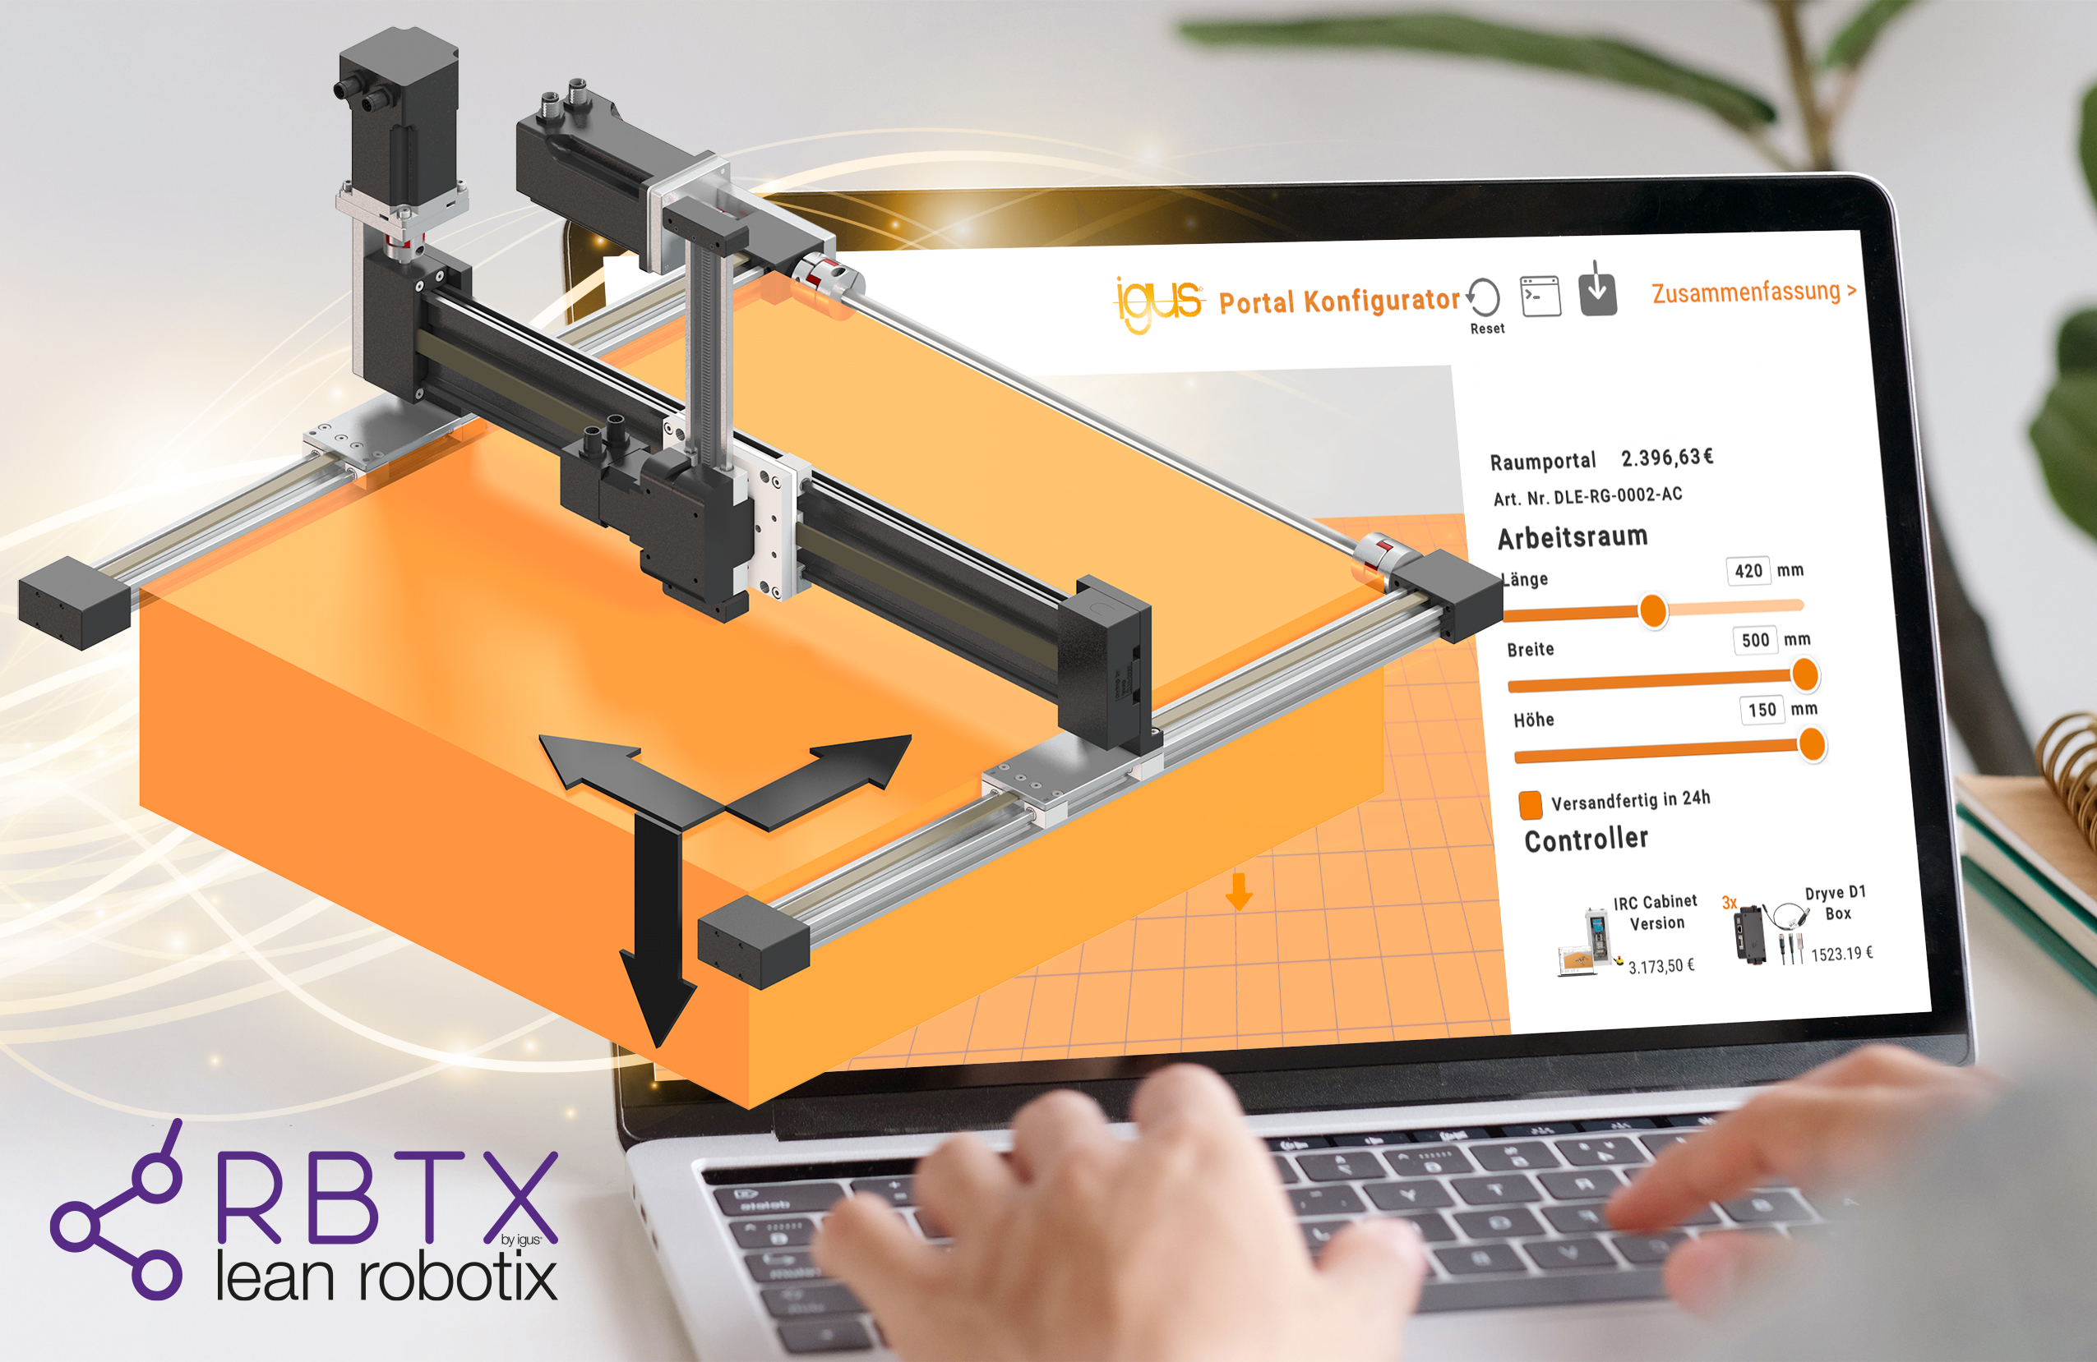
Image PM6121-1
Schnell, simple and inexpensive automation: The new online portal configurator from igus helps with this. (Source: igus GmbH)

PRESS:

Oliver Cyrus
Head of Press and Advertising

igus® GmbH
Spicher Str. 1a
51147 Cologne
Phone 0 22 03 / 96 49-459
ocyrus@igus.net
www.igus.de/presse

The terms "igus", "Apiro", "chainflex", "CFRIP", "conprotect", "CTD", "drygear", "drylin", "dry-tech", "dryspin", "easy chain", "e-chain", "e-chain systems", "e-ketten", "e-kettensysteme", "e-skin", "e-spool", "flizz", "ibow", "igear", "iglidur", "igubal", "kineKIT", "manus", "motion plastics", "pikchain", "plastics for longer life", "readychain", "readycable", "ReBeL", "speedigus", "triflex", "robolink" and "xiros" are legally protected trademarks in the Federal Republic of Germany and if necessary also internationally.

