ROIBOT 2022: igus is looking for exciting applications with cost-effective robotics
The prize for automation solutions with a fast return on investment goes into the 2nd round

Cologne, 9. September 2021 – You automate packaging, sort goods and help with dangerous tasks in everyday work: cost-effectiveroboticsand automation solutions fromigus. In 2022, the motion plastics specialist will once again honour the most creative applications with the ROIBOT Award. We are looking for projects that have been able to achieve a fast return on investment with the help of igus Low Cost Automation and drylin drive axles. The winners will receive a freely selectable robotics package from the marketplace RBTX.com worth up to 5,000 euros.

More than 70 applications from all over the world were received last year for the ROIBOT Award 2019/2020. The award honors automation projects that use cost-effective robotics and automation solutions from igus. The winners from Salzburg (Austria) were able to look forward to a prize money of 5,000 euros. The students designed a mobile robot system with gripper to implement dangerous handling tasks from a distance, for example in the craft sector. In addition, a glove equipped with sensors is used, which enables intuitive control through gestures and with feedback. For the cost-effective and maintenance-free robolink D articulated arm from igus, the engineers developed a drive system, a battery system and a mechanical scaffold. The project convinced the expert jury and won first place. Second place went to Apostore's Pick & Place system for the healthcare sector. It consists of a robot cell and a supply system for the bulk goods to be supplied. Third place went to the German company Superwurm. With the help of igus Low Cost Automation, the earthworm breeders developed a system that automatically counts worms and packs them in cans.

ROIBOT Award enters the next round in 2022
The ROIBOT competition is once again looking worldwide for existing low-cost automation applications that have led to a quick return on investment. Robolink articulated arm robots, drylin delta robots, Cartesian robots and drylin drive technology from igus can be used. An expert jury evaluates the concepts. An exciting submission, which is characterized by creativity and an optimization idea, leads to a high rating. The winner will receive a freely configurable robotics package worth 5,000 euros, the second place can choose automation solutions on RBTX.com for 2,500 euros and the third place for 1,000 euros. The closing date for entries is 30 April 2022. The award ceremony will be held by igus at automatica 2022 in Munich, the leading trade fair for intelligent automation and robotics. On the website igus.de/roibot-anmeldung, participants can apply.

Take a look at the winners of the ROIBOT Award 2019/2020 now: https://youtu.be/HAvJHEvj-pU

Caption:

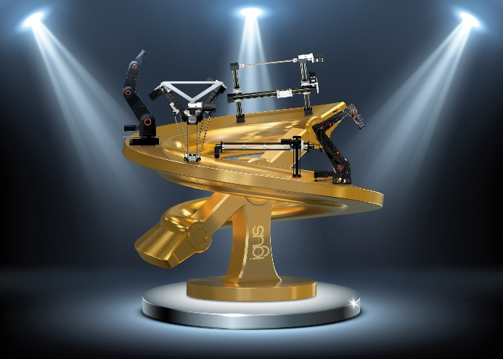
Image PM4621-1
The ROIBOT Award from igus is looking for creative automation solutions that have achieved a quick return on investment. (Source: igus GmbH)

ABOUT IGUS:

igus GmbH develops and produces motion plastics. These lubrication-free high-performance plastics improve technology and reduce costs wherever something moves. igus leads the global markets for energy supply systems, highly flexible cables, plain and linear bearings as well as thread technology made of tribopolymers. The family-owned company based in Cologne is represented in 35 countries and employs more than 4,500 people worldwide. igus generated a turnover of 7,27 million euros. Research in the industry's largest test laboratories is constantly producing innovations and greater safety for users. 234,000 items are available from stock and the service life can be calculated online. In recent years, the company has also expanded through internal start-ups, for example for ball bearings, robot gears, 3D printing, the RBTX platform for lean robotics and intelligent "smart plastics" for Industry 4.0. The most important environmental investments include the "chainge" program – the recycling of used e-chains – and the participation in a company that recovers oil from plastic waste. (Plastic2Oil).

PRESS CONTACTE:  Oliver Cyrus  Head of Press and Advertising  igus® GmbH  Spicher Str. 1a  51147 Cologne  Phone 0 22 03 / 96 49-459  ocyrus@igus. net  www.igus.de/presse | Anja Görtz-Olscher  Manager Public Relations  igus® GmbH  Spicher Str. 1a  51147 Cologne  Phone 0 22 03 / 96 49-7153  agoertz@igus.net  www.igus.de/presse

The terms "igus", "Apiro", "chainflex", "CFRIP", "conprotect", "CTD", "drygear", "drylin", "dry-tech", "dryspin", "easy chain", "e-chain", "e-chain systems", "e-ketten", "e-kettensysteme", "e-skin","e-spool", "flizz", "ibow","igear", "iglidur", "igubal", "kineKIT", "manus", "motion plastics", "pikchain", "plastics for longer life", "readychain", "readycable", "ReBeL", "speedigus", "triflex", "robolink" and "xiros" are legally protected trademarks in the Federal Republic of Germany and, if applicable, internationally.

