Energy and data combined in new igus hybrid cable for SEW motors

New flexible chainflex cable saves 40% space in
e-chains and ensures secure energy and data transmission

The next generation of motors are designed to be small, compact, and fast, and more and more drive manufacturers are relying on hybrid technology to save space. In response, igus has now expanded its range of hybrid cables with a new cable especially for motors from SEW EURODRIVE with the MOVILINK DDI interface – the CF280 hybrid cable. For example, material handling companies can now rely on a durable cable specially developed for e-chain use.

Hybrid cables for drive technology are characterized by combining energy and data transmission in one cable, halving the number of cables required. In the case of the new SEW motors with a MOVILINK DDI interface, the drive manufacturer relies on a coax element for the data transmission of motor information. To be able to supply these compact motors with energy and data safely, even in motion, igus has now developed a new hybrid cable.

"The challenge that cables with coax elements have is that they are susceptible to interference under high dynamics,” says John Barker, Product Manager of chainflex cables at igus UK. “We have set ourselves the task of developing a durable and flexible system that also works reliably in motion."

Motion plastics and cable specialist igus can draw on 20+ years of expertise in the field of coax cables for highly dynamic applications, in developing the new CF280 hybrid cable with four power cores, with one coaxial core and two control pairs that have now been merged. By merging two cables into one, users can save 40% of space in the energy chain. This reduces the weight that must be driven by the system, consuming less energy. The new cable, with a PUR coating outer jacket, can be used for applications with a bending factor down to 15 x d (diameter) and is therefore suitable for a wide variety of industries, from machine tools to material handling and for cables in automotive applications.

28 cables for hybrid technology
With 28 different hybrid cables for motors from Siemens, Beckhoff, SEW and Bosch Rexroth, igus already has the largest portfolio of hybrid cables for energy chains in stock. With the expansion of the CF280 series, igus is moving with the trend of hybrid technology, combining energy with data to save space and weight. igus also offers its CF280 cable series with a PVC outer jacket as the CF220 model, by doing so reducing additional costs in the hybrid cable segment. The chainflex cables can be assembled or purchased by the metre. As with all its cables, igus offers a warranty of up to 36-months on the new SEW hybrid cable.

More information about igus hybrid cables:

https://www.igus.co.uk/info/n21-cf-hybridcable-for-sew

For further information, please contact:

Erin Kemal
Tel: 01604 677240
Email: ekemal@igus.co.uk

Hannah Durrant
Tel: 01604 677240
Email: hdurrant@igus.co.uk

Caption:

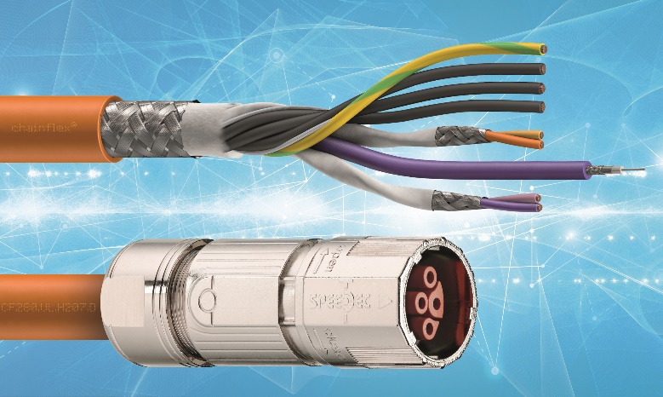
Image PM5721-1
With the new hybrid cable from igus for the SEW MOVILINK DDI interface, users save space on both the motor and in the energy chain. (Source: igus GmbH)

The terms "igus", "Apiro", "chainflex", "CFRIP", "conprotect", "CTD", "drygear", "drylin", "dry-tech", "dryspin", "easy chain", "e-chain", "e-chain systems", "e-ketten", "e-kettensysteme", "e-skin", "e-spool", "flizz", "ibow”, “igear", "iglidur", "igubal", "kineKIT", "manus", "motion plastics", "pikchain", " plastics for longer life", "readychain", "readycable", "ReBeL", "speedigus", "triflex", "robolink" and "xiros" are legally protected trademarks in the Federal Republic of Germany and, if necessary, internationally.

