Evolution of the trapezoidal thread: new igus standard achieves 82% efficiency
Harmonised lead screws and lubrication-free lead screw nuts in trapezoidal threads extend service life by 30%.

Motion plastics specialist igus has refined the classic trapezoidal thread, achieving a 30% service life extension – a huge increase for a well-established mechanical part. Thanks to a special geometric interaction between the lead screw nut, which requires no lubrication or maintenance, and the metal lead screw, dryspin technology promises a long service life, improved efficiencies, reduced wear and quieter operation. And now dryspin lead screw technology is available in eight new sizes.

Trapezoidal threads have been classical mechanical engineering designs for decades. The machine elements convert rotary motion into linear motion – in applications such as window and door drives, format adjustments in production plants and laboratory technology.
However, almost every classic design has the potential for improvement. "We have tackled a market standard and are able to say that we can do even better," says Robert Dumayne, drytech director at igus UK. The igus design relies on an optimised interaction between the metal lead screw and the plastic lead screw nut geometries.
30% longer service life, 82% efficiency
Both the nut's thread flanks and the width of the lead screw are larger than those of classic trapezoidal thread. This is a small change, but it has big consequences: enlarging the thread flank means that more high-performance plastic is used for power transmission. This means more material that is tribologically optimised, i.e., reducing friction and wear. "The asymmetry has enabled us to extend the service life so that it is about 30% longer than that of symmetrical trapezoidal threads", Dumayne says.
He adds “Optimising the flank angle also increases the amount of energy supplied that is actually used. We have flattened the flank angles of the lead screw nut and lead screw, this gives us above average efficiency – up to 82% at high pitches."

Lead screws work almost silently and without vibration
The new dryspin thread technology is not only durable and efficient, but also quieter than many conventional trapezoidal threads, because the tooth flanks are not angular but rounded, reducing the contact area between lead screw nut and lead screw. This leads to less vibration, which can take the form of rattling or squeaking. Dumayne says: "The rounded tooth flanks allow the lead screws to move without vibration and almost silently. The lead screw manufacturing tolerance is tighter than that specified in DIN 103 7e, ensuring more precise operating behaviour and allowing for much higher speeds in the application."

Eight more installation sizes added to the dryspin lead screw portfolio
igus began to establish its own lead screw technology on the market in 2013, initially as an alternative to high helix threads. Now there are eight new installation sizes – both harmonised lead screws and lead screw nuts, including dimensions with low pitches that enable quick one-to-one replacement of installed trapezoidal threads.

The new lead screws are available with pitches of 6.35x6.35 RH, 8x40 RH, 10x3 LH, 12x25 LH, 14x4 RH, 16x5 RH, 18x4 RH and 20x10 RH. They are made of stainless steel or aluminium, and the lead screw nut material can be selected from seven high-performance plastics and several geometries – from a cylindrical design with flange or spanner flats to a version with spring pre-load.

For further information, please contact:

Erin Kemal
Tel: 01604 677240
Email: ekemal@igus.co.uk

Hannah Durrant
Tel: 01604 677240
Email: hdurrant@igus.co.uk

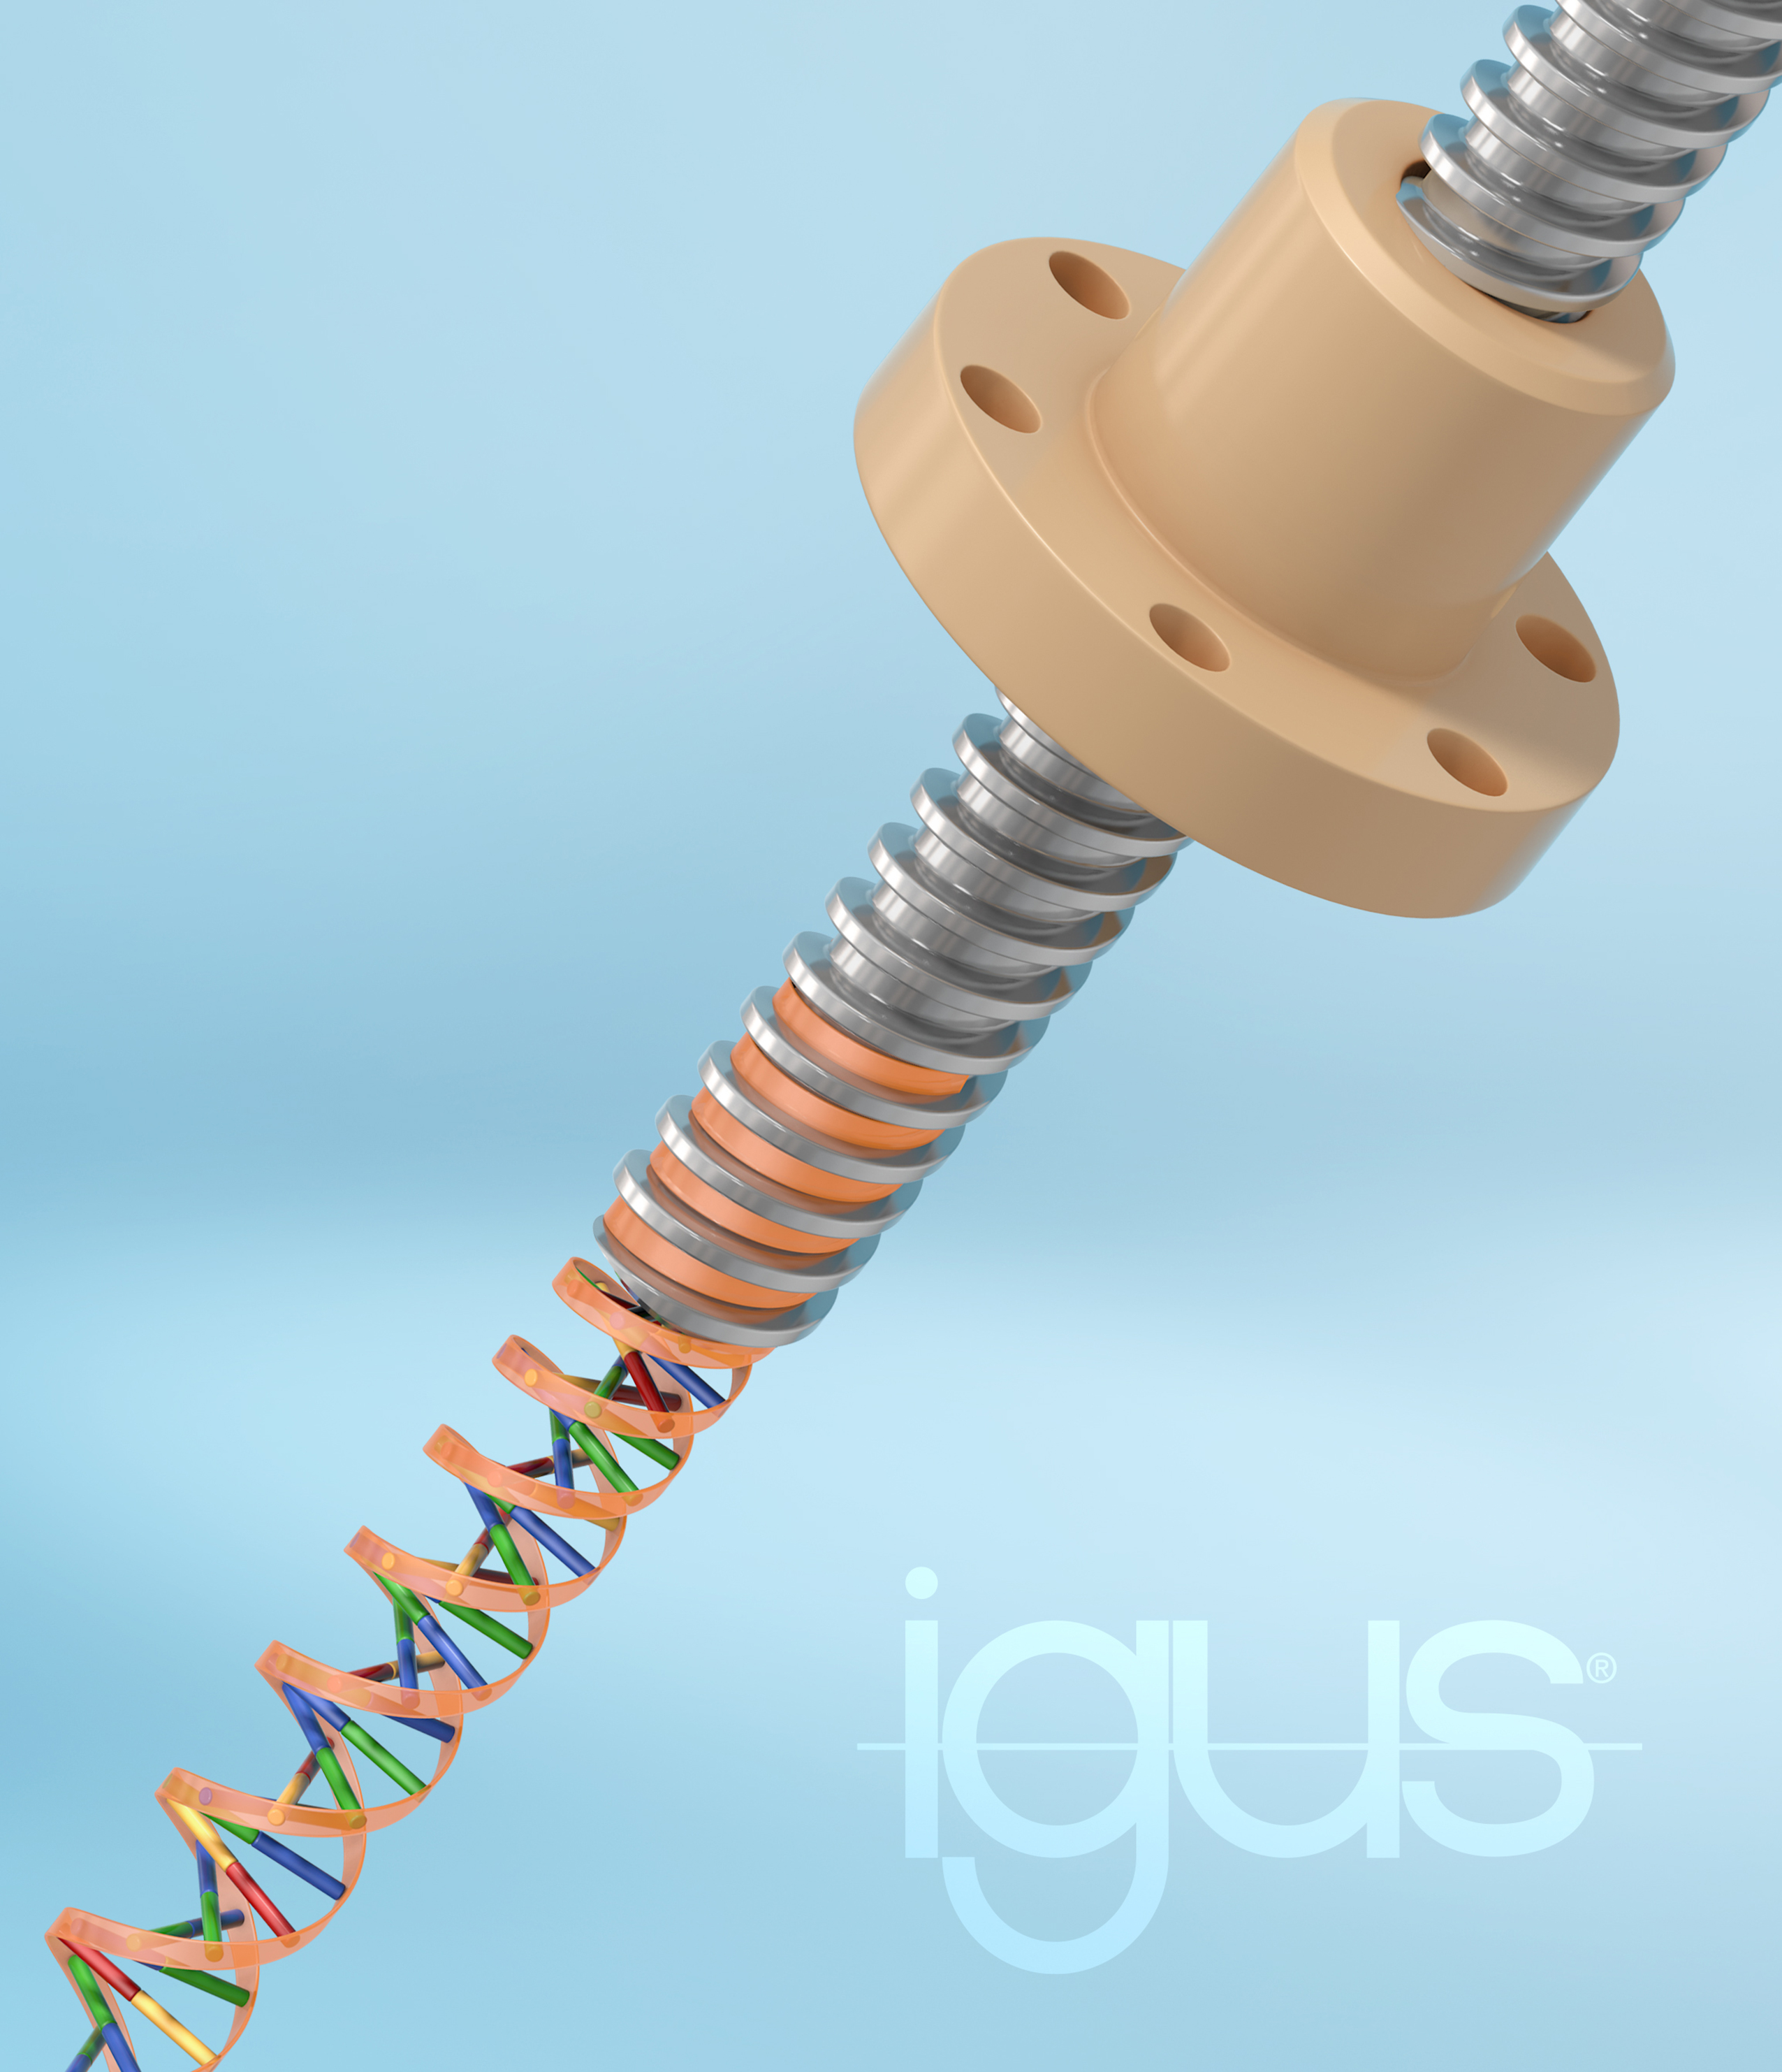
Picture PM1022-1
Caption: The evolution of the trapezoidal thread: wear and noise reduction, and now up to 30% longer service life and high efficiency. This is an igus promise with its dryspin technology (Source: igus GmbH)

The terms "igus", “Apiro”, "chainflex", "CFRIP", "conprotect", "CTD", “drygear”, "drylin", "dry-tech", "dryspin", "easy chain", "e-chain", "e-chain systems", "e-ketten", "e-kettensysteme", "e-skin", "e-spool”, "flizz", “ibow”, “igear”, "iglidur", "igubal", “kineKIT”, "manus", "motion plastics", "pikchain", "plastics for longer life", "readychain", "readycable", “ReBeL”, "speedigus", "tribofilament“, "triflex", "robolink", “xirodur”, and "xiros" are protected by trademark laws in the Federal Republic of Germany and internationally, where applicable.

