The ReBeL of low cost automation: smart igus cobot

The world's first plastic gearbox for cobots and access to a digital ecosystem: latest igus Low Cost Automation product records 20 new projects per week in Germany alone

Low cost and about 8kg, the plug-and-play ReBeL cobot is one of the lightest cobots on the market. Digital services provided with it, such as the RBTXpert and new online offerings, enable customers to create complete automation solutions in just a few days that don't break the bank.

The ReBeL cobot relies entirely on igus’s motion plastics expertise: all-plastic design makes the robot, whose net weight is 8.2 kilogrammes, the lightest service robot with cobot function in its class. igus produces all the ReBeL's constituent mechanical components. Its payload is 2kg and it has a reach of 664m. Repeatability is +/- one millimetre at seven picks per minute. And at its core is the world's first industrial-grade cobot gearbox made entirely of plastic.

Behind these numbers are 1,041 tests that have been run in igus’s in-house laboratory since 2019, including tribological and thermodynamic tests on 15 material combinations and tolerance chains. “A particularly big challenge was the heat generation in the fully integrated strain wave gear units, which are thermally influenced by the motor,” says Adam Sanjurgo, Product Manager of Low Cost Automation at igus UK. “In the development phase, we therefore also focussed on larger motors and better efficiency to significantly reduce heat generation.” He adds, "This enabled us to continuously improve and ultimately multiply the number of cycles by five, to two million, which is equivalent to a normal service life of two years."

Smart plastics – full transparency for preventative maintenance
igus has also applied its motion plastics knowhow to power electronics, and for the first time has developed an encoder using conductive plastic tracks. This allows the temperature, electrical current and number of rotations, cycles and iterations to be measured precisely. A webcam with a cloud connection supplies date to a dashboard that clearly displays all captured data live. This gives customers full visibility of their ReBeL cobot’s key indicators, such as wear, cycle time and quantities, during operation.

Inexpensive complete solution, quick to integrate
The smart ReBeL is available in two variants: one is an open-source version without a robot control system, power supply unit or software; the other is a plug-and-play variant including robot, control software and power supply . In line with the igus "build or buy" approach, in addition to the complete system customers can choose from different individual ReBeL strain wave gears (diameters of 80 and 105 millimetres). Torque is 3Nm (80) or 25Nm (105) at 6rpm, with a transmission ratio of 50:1.

The ReBeL is available on the RBTX online marketplace, where users can shop for individual components, integration support, hardware and software from more than 40 partners – knowing that every component on the platform is 100% compatible with everything else. This includes a wide variety of robot kinematics, cameras, software, grippers, power electronics, motors, sensors and control systems.

The RBTXpert service is available for customers to help with integration using online consulting with a fixed-price guarantee. In a 400m² customer testing area, experts advise customers daily via live video and send solution proposals within hours.
Typical hardware costs without integration start at £8,500, and complete solutions are available from £12,500. "We feel that we are making automation even more accessible, since we provide advice for more than 20 customer projects per week in Germany alone with the RBTXpert service,” says Adam Sanjurgo. “Now we are expanding the service, by adding 10 more online consultants by the end of March. Internationally, the service is already available in seven countries, with another 14 in the pipeline. These positive experiences, the many projects implemented, and the numerous customer discussions are giving rise to an exciting ecosystem of further services."

Low Cost Automation universe – new business models
In this “Low Cost Automation universe”, everything revolves around the individual customer application. The goal is to further simplify component integration with new offerings and different business models.

"We will provide an app store where Low Cost Automation vendors and free software developers can contribute their software ideas,” says Sanjurgo. “By leveraging existing software, users can implement their automation even faster. They can connect the robots to digital services such as IFTTT or smart assistants like Alexa or Siri. Visitors can then engage in activities such as ordering their favourite coffee by voice, which the robot then serves.”

“This gives rise to entirely new business models, such as pay-per-pick, where users don't pay for the robot, but only for its services,” adds Sanjurgo. “These new capabilities will permanently change the robotics market, and everyday life along with it. We want to give them a home in the Low Cost Automation universe."

Image and caption:

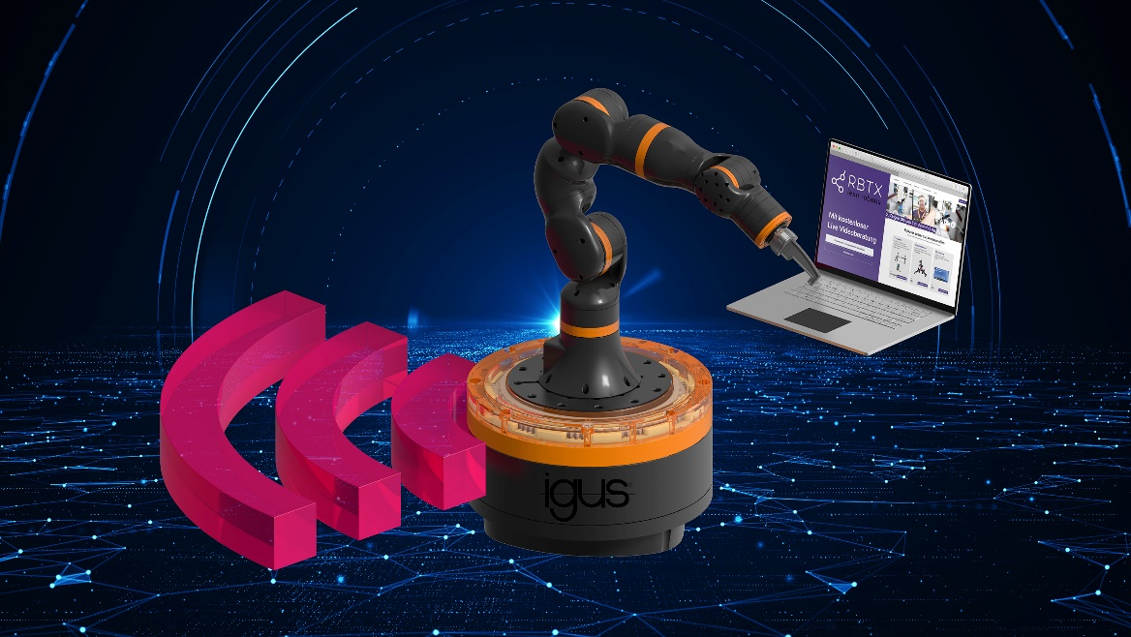
Picture PM1122-1
The core is the all-plastic gearbox – the ReBeL cobot is now available for €4,970 including power supply, and access to a digital universe for low-cost integration in just a few days.
(Source: igus)

For further information, please contact:

Erin Kemal
Tel: 01604 677240
Email: ekemal@igus.co.uk

Hannah Durrant
Tel: 01604 677240
Email: hdurrant@igus.co.uk

The terms "igus", “Apiro”, "chainflex", "CFRIP", "conprotect", "CTD", “drygear”, "drylin", "dry-tech", "dryspin", "easy chain", "e-chain", "e-chain systems", "e-ketten", "e-kettensysteme", "e-skin", "e-spool”, "flizz", “ibow”, “igear”, "iglidur", "igubal", “kineKIT”, "manus", "motion plastics", "pikchain", "plastics for longer life", "readychain", "readycable", “ReBeL”, "speedigus", "tribofilament“, "triflex", "robolink", “xirodur”, and "xiros" are protected by trademark laws in the Federal Republic of Germany and internationally, where applicable.

