World's first tribo material for DLP 3D printing from igus gives up to 60x longer service life
iglidur i3000 makes 3D digital light processing (DLP) printing of very durable parts in the millimetre range possible

iglidur i3000 from igus is the world's first resin formulated specifically for DLP 3D printing of parts subject to wear. This enables additive manufacturing of particularly small and precise components with a service life 30 to 60 times longer than conventional 3D printing resins. At the same time, igus is expanding its 3D printing service to include DLP (Digital Light Processing) printers that achieve a resolution of 0.035mm.

For making components at the millimetre scale, 3D printers that use the DLP process are particularly suitable. The DLP process achieves a very fine resolution among the various 3D printing technologies. Resolutions of just 0.035mm – about half as thick as a human hair - possible are. To achieve this, a projector emits layer by layer of the 3D model onto the surface of a special liquid resin. The layers connect and fuse under the influence of light. After curing a layer, the build platform is lowered by a single layer for the next exposure. Layer by layer, tiny components are created, for example gears whose tips are only 0.2mm thick and which have an extremely smooth surface without post-treatment.

With the new 3D printing resin iglidur i3000-PR, 3D printing users can now benefit from igus' tribo technology and thus greatly increase the service life of their moving application.
Increasing the service life by 60x is possible
As accurate as DLP 3D printing is, it also has a dark side. “A common problem is that tiny components made of commercially available 3D printing resins, such as gears for model making, are not particularly robust and can fail quickly," explains Dean Aylott, Product manager for 3D printing at igus UK. This was the driver for igus to develop iglidur i3000 for DLP 3D printing, which is tribologically-optimised (lubrication-free) and thus more wear-resistant. "We were able to prove in laboratory tests that the service life of iglidur i3000 is at least 30 times longer compared to 10 commercially available 3D printing resins. In some applications, we even expect an increase in service life by a factor of 60,” says Dean Aylott. Another advantage is that he maintenance effort for lubrication is zero, because there is no oil or grease to replace. Microscopically small solid lubricants are integrated into the material, which release independently during movement.
Tiny special components produced quickly
In addition to the 3D printing resin, customers can order components made from iglidur i3000 directly from igus and in addition expanding its 3D printing service. While customers were previously able to choose between the selective laser sintering (SLS) and fused deposition modelling (FDM) 3D printing processes, now they will also be able to order components manufactured with DLP 3D printers.

The finest details and even inner channels can be easily produced. “We have now started the beta test phase with our first customers. We are concurrently working to ensure that DLP 3D printing is also available in the online tool that allows users to upload STEP files of their components, or to configure gears with just a few clicks," says Aylott.
He adds: "Thanks to the combination of 3D printing and online configuration, weeks of waiting time for wear-free special components is now in the past. In 2021, igus produced more than 200,000 3D printed abrasion-resistant components in Cologne, in quantities of one to 10,000. Especially when there are bottlenecks and disrupted supply chains, 3D printing is a real, viable alternative. "

For further product information, contact:

Erin Kemal
Tel: 01604 677240
Email: ekemal@igus.co.uk

Hannah Durrant
Tel: 01604 677240
Email: hdurrant@igus.co.uk

Image and caption:

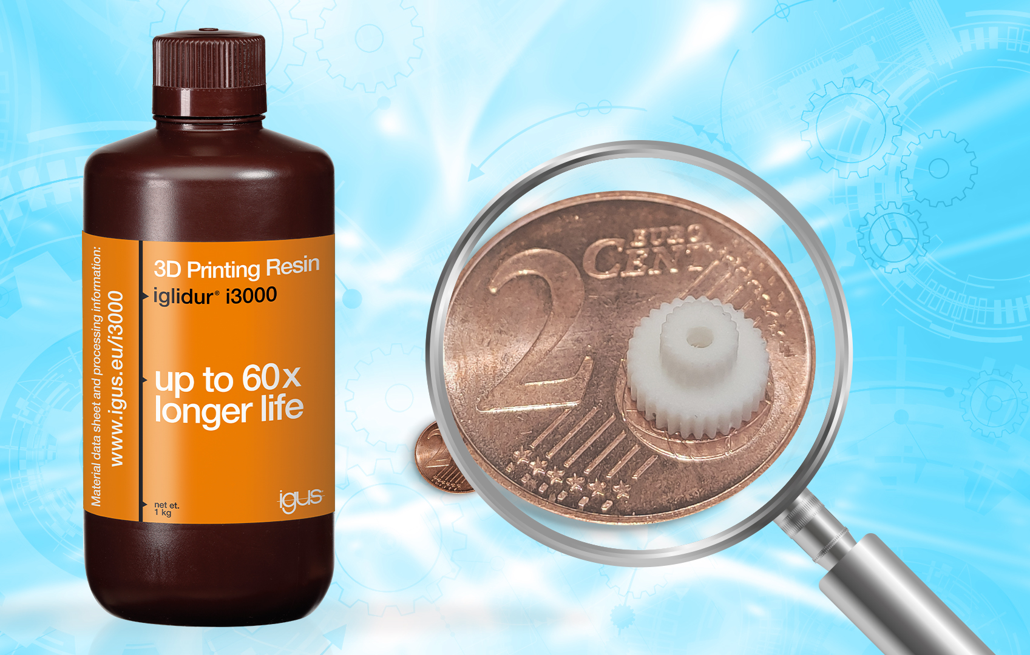
Picture PM2222-1
The new 3D printing resin from igus enables additive manufacturing of the smallest wearing parts, with a service life of 60 times longer than standard resins. (Source: igus GmbH)

The terms "igus", "Apiro", "chainflex", "CFRIP", "conprotect", "CTD", "drygear", "drylin", "dry-tech", "dryspin", "easy chain", "e-chain", "e-chain systems", "e-ketten", "e-kettensysteme", "e-skin", "e-spool", "flizz", "ibow", "igear", "iglidur", "igubal", "kineKIT", "manus", "motion plastics", "pikchain", "plastics for longer life", "readychain", "readycable", "ReBeL", "speedigus", "triflex", "robolink" and "xiros" are legally protected trademarks in the Federal Republic of Germany and if necessary also internationally.

